WIRRAL DRSS

SCREENING PROTOCOL

Oct 2023

Please note that adherence to this protocol forms part of the contractual arrangement between providers and the programme.

Failure to comply with the protocol constitutes a breach of contract.

Contents

1. Screening Pathways 3
2. Screening Staff 6
3. Invitation for screening 7
4. Accessing patient’s screening records 8
Data entry & Additional Data 9
5. Making Appointments 10
6. Visual Acuity 11
7. Dilation 12
8. Pregnancy 14
9. Ocular History 16
10. Eye Tests at the same time as screening 17
11. Image Capture 18
12. Poor quality images 20
13. Prioritising Image sets 21
14. Completing image capture 22
15. Patient feedback 24
16. Technical Failure 24
17. Potential OCT problems 24
18. Making notes 25
19. Referrals following screening 26
20. Grading protocols & feedback 27
21. Resources 31
22. Internal QA and equipment maintenance 32
23. POOR PERFORMANCE PROTOCOLS 32/33

Appendices

Safety and Hygeine 34
Additional Data 35/36

- Screening Pathways
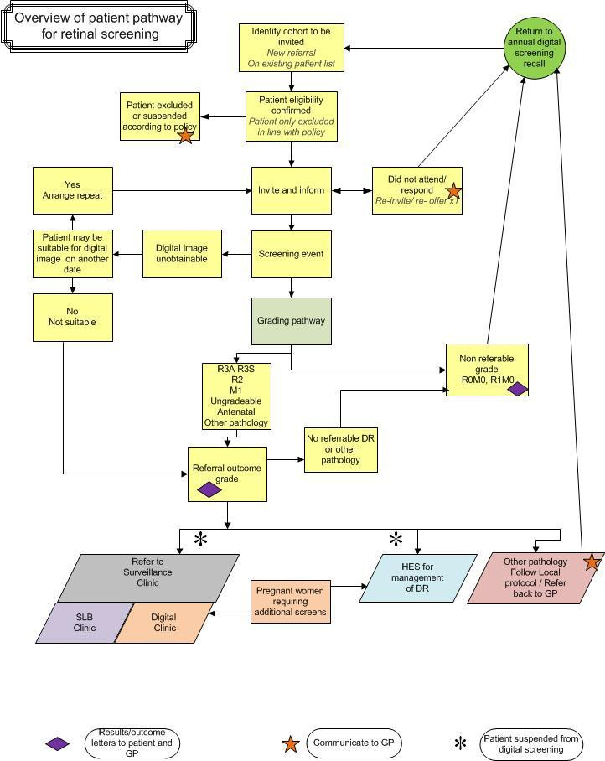

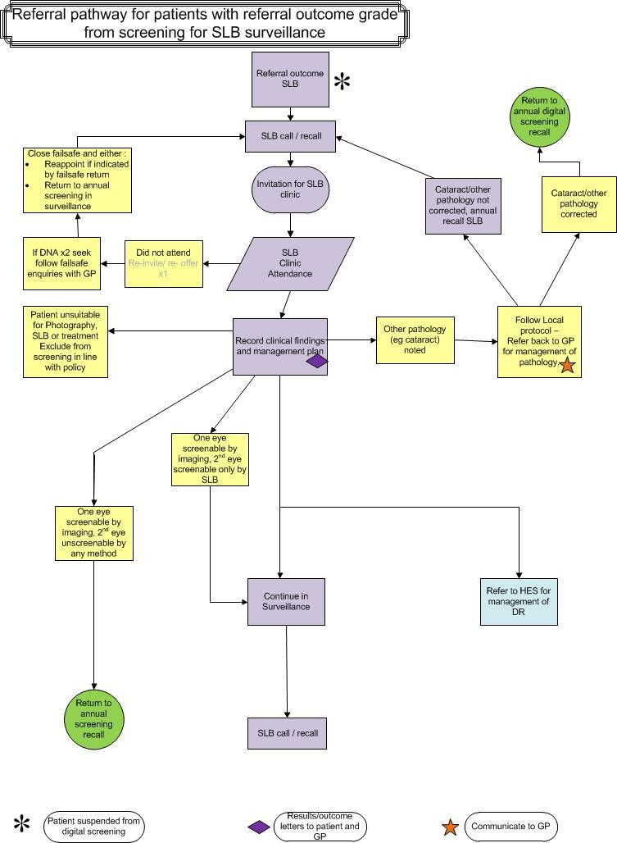

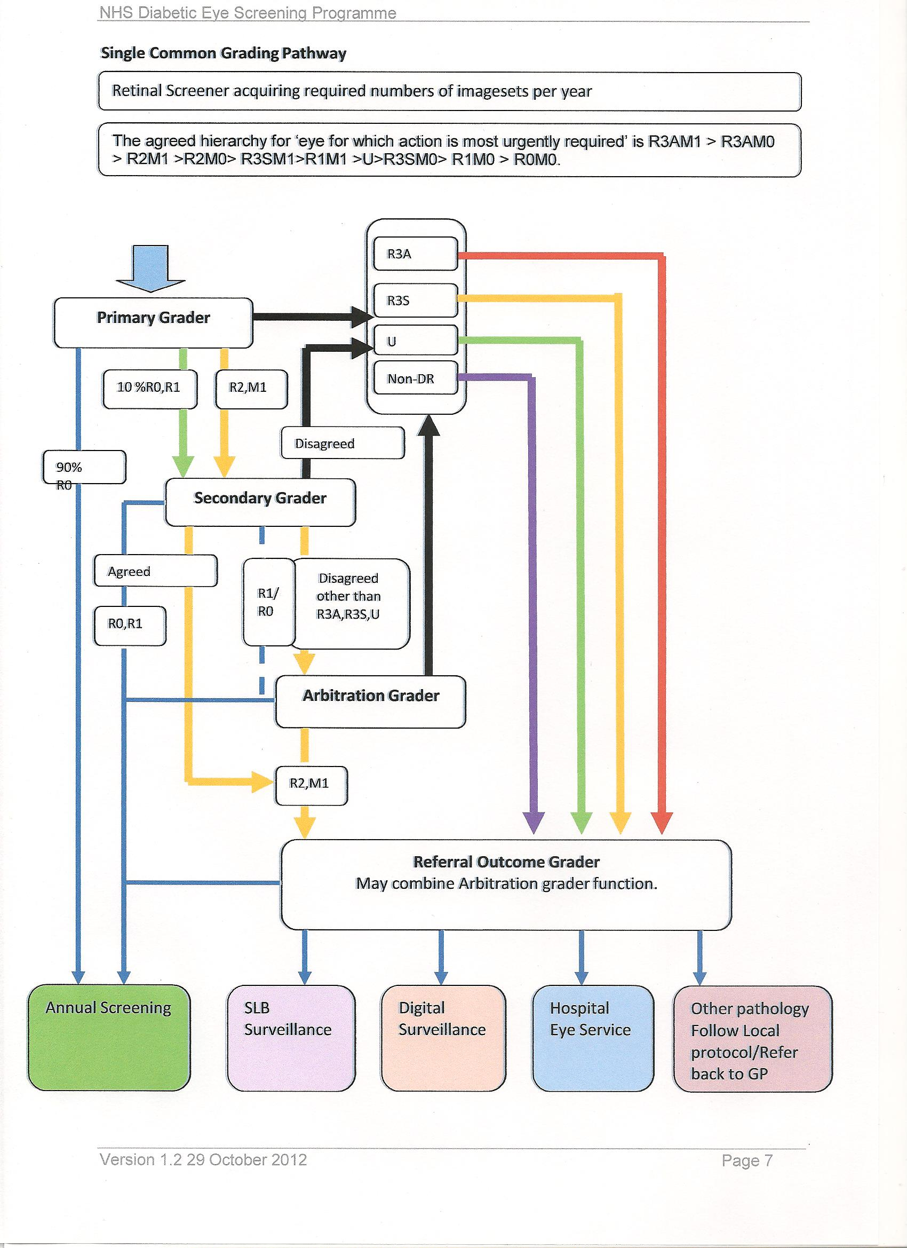
2. Screening Staff

All members of staff carrying out work for the programme will need to be on the Registered Staff list. The list will include the following staff categories:

- Programme management and administration
- Clinical Review/Gatekeeper graders
- Graders
- Screeners

A process for any prospective new Grader/Screener or a new participating practice, is available.
Please contact the programme managers or Optometric lead for consideration.

Once approval is granted the staff member will be given a unique username for OptoMize.

Every member of staff will have their own username and log-in password.
Under no circumstances must this username be used to work in OptoMize by anyone else. Any transgression will lead to immediate suspension from the programme pending disciplinary measures. This may lead to removal from the programme.

Qualifications
Initially required City & Guilds

Particular requirements for staff working in the programme are as follows:

- Only registered Screeners can undertake any screening functions within the programme
- Lay Screeners may take additional modules to enable them to measure
VA and instill drops
- All screeners must complete the relevant national accreditation 2 years after first being in post. After this period, the screener can only work under supervision from a screener who has passed the relevant C&G modules. The supervising screener must be on the premises at all times. Any transgression will lead to immediate suspension from the programme pending disciplinary measures. This may lead to removal from the programme as well as referral to any relevant professional body, e.g. GOC.
- The programme management reserves the right to restrict the number of registered screeners/graders per screening venue, to ensure all screeners obtain sufficient regular experience to maintain expertise

3. Invitation for Screening

Inclusion criteria

- All people aged 12 years old and over diagnosed with diabetes (type I or type II); and
- Registered at a GP practice within the boundaries of NHS Wirral
- The unregistered population living within the boundaries of the programme; or
- Any others deemed appropriate by the programme manager.
- Please note this includes patients falling into the above categories who are under the care of an ophthalmologist for other eye disease

Exclusion criteria

- People with no perception of light at all
- People who exclude themselves having made an informed choice to do so
- People who have been excluded on the advice of the clinical leads, for instance:
- People who are too unwell to participate
- People with physical or mental disabilities which prevent either screening or treatment
- People under the care of an ophthalmologist for treatment and/or follow-up of diabetic retinopathy

4. Accessing Patient’s Screening Records

For access to the patient’s screening records via the VPN token access at an optometry site, you will require the following information:

- NHS Number
- Patient’s date of birth (to confirm correct patient)

For access to the patient’s screening record at an NHS site, you will only require the NHS Number.

If the patient requests or attends for screening, but does not have their invite letter, the NHS number can be obtained from the Screening Office. To request the NHS number, the screening venue must supply all of the following information, with the permission of the patient:

- Full name
- Date of birth
- Full address

Acceptable access

- Receptionists, not registered with the programme as screeners, can only access the software to make and alter appointments once the patient has made an appointment and given the practice their NHS number and date of birth. They must not access or review the patient’s screening record

- Access to a patient’s screening record card is acceptable only by a screener registered to the programme. Screeners and graders may only access the records for up to three months after the screening date. This will be required for the following:

- Making and altering appointments
- Capturing images
- Grading images (registered graders only)
- Reviewing screening outcome

- Access to a patient’s screening record card three months after the screening date is unacceptable and could lead to disciplinary action and ultimately suspension or removal from the programme

- If circumstances occur where you need access after this 3 month period, contact the Programme managers either in writing or by email

- State the reason why you require access
- The programme management will make the final decision to grant access
- It may be necessary to seek consent from the patient

Data Entry

Screeners should not, under any circumstances, change any patient demographic data, e.g. name, address, NHS Number. This data is critical to maintaining data integrity between the software and GPs/Hospitals. It should only ever be changed by the screening Administration Team.

If a screener finds an error in any demographic data, they should report the error to the Programme managers immediately.

SCREENERS OR THEIR STAFF SHOULD NEVER CHANGE ANY
DEMOGRAPHIC DATA THEMSELVES

Additional Data.

However, the following is now a mandatory requirement

To assist with a health inequality audit, Public Health England have been requested we collect further data.

This will assist in identifying population and area ‘hotspots’ of poor screening uptake.

From the first Patient Screen, you will see a QUICK UPDATE box on the left hand side.
This screen has several more drop-down boxes for additional demographic information.

Please complete as many boxes as possible.

Example screenshots (provided to everyone in September 2014) are included at the end of this document

5. Making Appointments

Once the patient has contacted the screening venue, the appointment MUST be made in OptoMize within 48 hours (72 if over a weekend), unless this is not possible. If it isn’t possible, this should be flagged up to the screening office and the reasons must be clearly reported in the patient’s screening record as soon as practically possible.

It is not acceptable for the time between making the appointment and it being entered into OptoMize to exceed 48 hours. This leads to dissatisfaction amongst patients who receive repeated invitations. Persistent failure to meet this requirement will lead to suspension, pending disciplinary measures and may result in removal of the screening venue from the programme.

Please note that any venue which is experiencing difficulties in fulfilling this requirement should contact the screening office at the earliest opportunity. The DESP office will do what they can to resolve any issues which prevent you from fulfilling this task but they can only do this if they are aware of the difficulty.

Patient Consent

When the patient has received their invite letter and booked an appointment at their choice of venue, the programme considers that there is implied consent. The onus is on the patient to exclude themselves from screening, if they so wish. Therefore, it is no longer necessary to obtain explicit consent from the patient at the time of screening.

However, optometry screeners may still prefer to obtain consent on the day of screening, particularly for patients attending for their first screening at the practice. If so, they can continue to use the standard consent form.

On the day of screening, ensure the “Consent given to hold and use screening details and for research purposes” tab has been ticked in both parts of the patient’s screening record. If the patient refuses to give this consent and to be screened, please record this and the reasons in pre-screening notes of their screening record, as well as informing the Programme managers at the screening office.

6. Visual Acuity

The VA should be measured using an appropriate test chart, which must be set at the correct working distance. VA should be recorded in the patient’s OptoMize record in all cases. Please give best VA only and use the various sub-levels to assist with audit.

The best VA will be:

- With spectacles, if brought
- With Contact lenses if wearing
- Best corrected VA after refraction if patient is having an eye test at the same time
- With Pinhole, if no visual correction brought, i.e. spectacles or contact lenses and the VA unaided is 6/12 or worse
- With Pinhole, if there is no current visual correction and the VA unaided is 6/12 or worse

The VA must be recorded in Snellen format.

It will be sometimes necessary to record a non-standard VA level:

- If the patient has a false eye, or it has been agreed that the eye is permanently unassessable, use the ‘missing eye’ box. Eye”. This eye will automatically drop out of the grading form and assist workflow.

- If it is impossible to satisfactorily measure VA, e.g. Learning Difficulties, Dementia or Language barriers select the “Not measured” option, where the software asks for “Visual Acuity Method”
- If the patient has VA in one eye worse than 3/60 or 6/120, set the VA as 3.00
- If the patient can only see Count-fingers(CF) or Hand-movements
- (HM), set the VA as 3.00
- If the patient can only just detect light, set the VA as “PL”
- If the patient cannot detect light at all, set the VA as “NPL”
- In all the above cases, clearly state the reasons for using these settings as “Comments” in the pre-screening section

7. Dilation

All invite letters inform the patient that they should not drive. Reception staff should repeat that when a diabetic appointment is initially made. Good practice would be to remind them when/if any confirmation telephone call is made and then again when the patient arrives for the appointment.

Every patient presenting for screening should be dilated, unless contraindicated. If the patient cannot be dilated at the time, e.g. if they are driving a further screening appointment may be arranged rather than proceeding to image capture without dilation.

The standard for dilating is 2 drops of 1% Tropicamide, one minute apart, in the Minims format, allowing at least 20 minutes for maximum effect. Using fewer drops is unlikely to offer any additional benefit in the average patient, as it makes it more likely they will need a further Slit Lamp screening episode.

It has been noted in some patients referred for slit lamp due to poor dilation, that using 1 drop of 2.5% Phenylephrine did enable adequate images to be obtained.

The following dilation procedure should be followed:

- Instill 2 drops of 1% Tropicamide, one minute apart
- Assess the effect of dilation after 20 minutes
- If dilation is sufficient, proceed to image capture
- If dilation is insufficient to capture satisfactory images, instill 1 drop of 2.5% Phenylephrine (Patient records should be annotated to suggest this is required)
- Ask the patient to wait another 20 minutes and then take best images possible

When used previously, it may be best to instill Phenylephrine at the same time as Tropicamide to reduce the time required for full dilation.

Drops should be procured, stored and used according to NSC protocol, as well as City & Guilds training (for lay Screeners) and the College of Optometrists guidance (for Optometrist Screeners).

Details of the drops, used, including dosage, batch number and expiry date should be recorded on the patient’s screening record. If 2.5% Phenylephrine is required, this should be recorded as “Comments” in the pre-screening section, including details of the batch number and expiry date.

Adverse Reactions to Mydriatic Drops

Where a patient suffers a known adverse reaction to dilated drops on the day of screening, this must always be reported in the patient’s screening record, once known. The correct procedure is as follows:

- In the pre-screening section:
- Select “Adverse Reaction to Mydriatic” in the Mydriatic Reaction Line
- Add a comment in the Pre-screening section explaining the circumstances
- Send a “Warning” message to the Failsafe Officer
- Refer the patient for medical attention, clearly stating what drops were
used, including the batch number and expiry date

At the time of screening a patient may mention that they experienced an adverse reaction after the last screening episode, although they didn’t report it to the programme at the time. Even if the patient recovered soon after and did not need to obtain medical attention, it is probably not safe to use drops this time. In these cases, take the best images possible undilated and follow the procedures above. The screening programme will decide on the best course of action if the images prove too poor to make a grading decision.

8. Screening during pregnancy

Significant retinopathy present at the start of the pregnancy can progress rapidly. Additionally, treatment can become difficult later in the pregnancy. Therefore, pregnant women need urgent HES attention and treatment needs to be carried out early.

As per NSC, all pregnant diabetics will be screened 3 times during their pregnancy, once in each trimester in a Digital Surveillance clinic.

The procedure for screening in pregnancy is as follows:

- Diabetic patient becomes pregnant.
- Diabetic Eye Screening office informed of pregnancy via Diabetic Specialist Nurse in Obstetrics using referral form.
- Patient flagged as pregnant on eye screening database Optomize. Expected date of delivery entered.
- Care pathway changed to ‘Move into Digital Surveillance’
- Letter generated from Optomize to patient and GP informing them of appointment.
- New Diabetic Photographer appointment generated on hospital system Cerner.
- Appointment letter from Cerner sent to patient along with letter from Optomize
- Digital Surveillance clinic created on Optomize and patient moved into clinic.

- If patient does not attend appointment, a letter will be generated on Optomize and sent to patient and GP.
- Patient will then be sent another appointment.

- If patient attends and no retinopathy found she will be recalled for Digital Surveillance in 3 months’ time.

- If retinopathy is found, the patient will be referred to HES for further investigations and possible treatment. The care pathway will be changed on Optomize to ‘Move into Ophthalmology’

- After delivery, the patient’s flag will be removed from Optomize and the care pathway will be changed back to Digital Screening for annual recall unless she is under the care of ophthalmology for treatment.

- Annual audit to be carried out to look at uptake of this service

Dilation

Dilation with 1% Tropicamide in Pregnancy

Although the NSC guidance advises that digital screening after mydriasis should be used in pregnancy it also states that Tropicamide should be used under the supervision of registered doctors in pregnant women.

PHENYLEPHRINE SHOULD NEVER BE USED WITH PREGNANT WOMEN

Screening Pathway During Pregnancy

9. Ocular History

All screeners must follow this procedure to ascertain the patient’s ocular history:

- Ask the patient if they have any current eye conditions
- Ask if they are currently under the care of the Hospital Eye Service and if so, for what reason
- Ask if they have had any eye conditions in the past
- Ask if they have ever had any eye treatment
- Ask if they have ever worn spectacles for distance vision
- Ask if they have had a recent eye test at the opticians
- If they haven’t had an eye test in over 12 months, advise them that they still need to have one at least annually, as the screening process does not identify all possible eye conditions

Record any eye conditions and eye treatment reported by the patient in prescreening comments, unless if it has been recorded previously and hasn’t altered. However, if the patient has a known history of ocular disease, always record whether or not they are currently under the Hospital Eye Service (HES).

Record in the pre-screening comments if the patient has not brought any spectacles they normally use for distance vision, even if not worn permanently.

If the patient attending only for screening mentions any recent ocular symptoms or concern about their eyesight, please advise them to go for an eye test as soon as possible, regardless of the outcome of screening. Also, tick the “Full eye test by optometrist recommended” tab in the pre-screening section and report this in comments.

10. Eye Tests at the Same Time as Screening
THIS PAGE IS DUE FOR EDITING. SOME POINTS N/A

Screeners must always fill in the “Full eye test given” field by choosing one of
the lines from the drop-down menu.

1. In many cases, the patient will have had an eye test at the time of screening, so where this applies, the option “Eye Test by Optometrist carried out” should be chosen

2. Patients are always encouraged in the invite letter to have a regular eye test as well as screening. If the patient attends only for screening and doesn’t have an eye test at the same time, the screener should routinely chose the “Full eye test by optometrist recommended” option

3. Chose “Full eye test by optometrist recommended” even if the patient indicates that they don’t wish to have an eye test. In these cases, the screener must always record this as “Comments” in the prescreening section

4. If the patient attends for screening only and the screener suspects other ocular pathology during the screening process, they should advise the patient to have an eye test and chose the “Full eye test by optometrist recommended” option. If appropriate, the optometrist carrying out the eye test should refer the patient in accordance with local protocols. (see section 18). In these cases, the screener must always record this as “Comments” in the pre-screening section or “Notes” in the capture screen section. They should also contact the Failsafe Officer by phone or email, stating all relevant details.

5. If the patient attends for screening and the screener suspects non-diabetic ocular pathology during the screening process, they believe requires urgent referral by their screening venue they should still chose the “Full eye test by optometrist recommended” option. The screener should refer the patient direct to the hospital eye service in accordance with local protocols (see section 18). They should also contact the Failsafe officer by phone or email immediately after making the referral, stating all relevant details. In these cases, the screener must always record this as “Comments” in the pre screening section or “Notes” in the capture screen section

6. In some cases “Eye test not recommended” may be chosen, e.g. If the patient has had one very recently and has no current symptoms, or signs of ocular disease on the images. If choosing this option, the screener must always record this as “Comments” in the prescreening section to confirm why an eye test is not advised

7. Screeners should not choose the “Eye test not recommended” option for any other reason, as non-diabetic ocular pathology may be found during the screening process

11. Image Capture

Updating Software

When the patient has attended for a screening appointment, the screener should access the patient record by clicking on the patient’s details in the front screen clinic list.

The screener must first establish they have the correct patient in front of them by asking the patient their date of birth and confirming if this is correct by clicking on Yes. If the answer is no, the screener should suspend the screening episode and call the Screening Failsafe Officer for further instructions. This should be repeated each time this screen is accessed.

The screener must then establish that the patient has given the required consent, or indicate on the rare occasions if they have not given consent.

Moving onto the next screen, the screener should always record the following:

- Whether a sight test was carried out or not (see section 10)
- The VA and how it was measured (see section 6)
- Details of the drops (see section 7)
- Whether there are any known reactions to drops (see section 7)

Camera Settings

Please see separate document.

Image Positions

The NSC policy document states the following:

Macular
- Centre of fovea _1DD from centre of image and vessels clearly visible within 1DD of centre of fovea
- Vessels visible across >90% of image
Adequate:
- Centre of fovea >2DD from edge of image
- Vessels visible within 1DD of centre of fovea

Nasal
- Centre of disc _1DD from centre of image and fine vessels clearly visible on surface of disc
- Vessels visible across >90% of image
Adequate:
- Complete optic disc >2DD from edge of image
- Fine vessels visible on surface of disc

Wherever possible, images should be taken in the order Right Macular/Right Nasal/Left Macular/Left Nasal. This will minimise errors, such as incorrect image field, missing or duplicate images. It will also avoid confusion for graders, who may record lesions for the wrong eye.

Additional Images

Where it is not possible to obtain ideal fields, screeners should attempt to take additional images at varying angles, so the full set of images covers all the area usually covered by the standard set.

12. Poor Quality Images

Screeners should make every attempt to obtain the best images possible during screening. Poor images should be retaken and the worst ones deleted. The screener should make a comment in the patient’s screening record if they have had difficulty obtaining good quality images. The main reasons for poor quality images, which should be recorded include:
- Cataract
- Poor dilation
- Ptosis
- External ocular condition
- Learning difficulties
Where there are media opacities, e.g. cataract or corneal lesions, screeners should take external images to demonstrate.

Artefacts

The main reasons for artefacts include:
- Dust
- Dirt
- Condensation
- Smudge

If there is an obvious artefact, make a comment in the patient’s screening record plus, as previously instructed,
Please annotate the first image of each set WITH AN ARROW.

Use elipses for Retinopathy.

All screening sites have a responsibility to ensure their camera is clean and free of artefacts.

13. Prioritising Image Sets

Once images have been captured, the screener must triage all image sets for the grading process. There are 3 choices within the capture screen and one must be chosen for each patient.

Red: R3a

- Where there are signs of advanced diabetic retinopathy, such as:
- New vessels, on the disc or elsewhere
- Pre-retinal/Vitreous haemorrhage
- Fibrosis

Amber: R2 M1

- Where there are signs of moderate Diabetic Retinopathy or Maculopathy, such as:
- Widespread and large haemorrhages, particularly in the macular area
- Exudates within the macula
- Vessel abnormalities
- Where it has only been possible to obtain a partial set of images
- If there are signs of other, non diabetic ocular disease on the images

Green:

- Where there are either no signs of diabetic retinopathy at all or only a few small blood spots visible

14. Completing Image Capture

Once all images have been taken, chose the most appropriate priority (see section 13) and click “finish”. The images may take up to 20 minutes to fully save in the database. To ensure all images have been uploaded to the screening programme database, undertake the following procedure:

- Click on “Resave Images” underneath “System Maintenance” on the main OptoMize screen
- Click start
- If there is an error message, take whatever action is advised in the message and also contact the Programme managers
- When the process is complete “Operation ended” will appear as the last line in the Status box
- Access the patient again via the Patient Review option
- See if the images are now all present and correct
- If not, contact the programme managers immediately and the screening office will assist in rectifying the situation
- If the images cannot be recovered, it may be necessary to re-screen the patient

Reviewing patient images

There are 2 possible ways to review patients, once screening is complete. As per section 4, screeners can review patients up to 3 months post screening, or once they have rebooked a screening appointment.

On the day of screening:

On the front screen, highlight the patient in the clinic list, by clicking on their information until the box is shaded. Click “Review” in the middle section of the screen. This will take you to the review screen mode, where you can see the images and make further comments in the “Patient Notes” tab.

After the day of screening:

On the front screen, under the heading “Clinical Tasks”, click the “Review patients” tab. Type the patient’s NHS number into the box headed “Patient’s name or ID” and click search. This will take you to the review screen mode, where you can see the images and make further comments in the “Patient Notes” tab.

15. Patient Feedback

As you are aware, our programme managers have worked hard to achieve excellent recall/uptake figures for screening episodes.
However, the HES have an unacceptably high level of DNA’s for clinic appointments and we need to eliminate any obstacle to attendance.
Optometrists can assist by ensuring the patient is fully aware of their condition.

Wirral DRSS does have non Optometrist Screeners who attended the original training evening and have completed their City & Guilds accreditation.
(ALL screeners must attend training events.)
However, it is unlikely that other non-Optometrists will be accepted as Screeners in the future.

This is due to the requirement for potential referral retinopathy to be discussed with the patient at the time of screening.

Screening should never take place without an Optometrist available to view any obviously significant retinopathy, discuss the images with the patient.

The majority of images can be reasonably assessed immediately after capture and although we should not say they have no retinopathy, it is acceptable to say there is nothing too significant. You may explain that if they get a letter saying ‘slight changes’ they shouldn’t be too concerned.

However, if there is referable retinopathy, or if the images are not clear and slit lamp may be required, this must be discussed with the patient. Please stress the importance of attending appointments.

If you use the ‘finish and review’ button, you will be able to manipulate and review the images stored on your computer even if still waiting for the images to transfer to Arrowe.

Please also remember the NSC requirement to take additional images if you see significant retinopathy at the edge of an image, or if the images are poor quality.

ALSO
Please make it clear when you are referring a patient for ‘other’ pathology, that they may still receive an appointment letter from Arrowe after having been informed that their screening was ‘normal’.

16. Technical Failure

An unfortunately regular occurrence is the failure of the VPN connection.

That and other potential equipment or connection issues may require Image capture and storage to be done on your own system.

Previous errors with then transferring to ORION (as was) and now OPTOMIZE resulted in a significant amount of training for both Screener/Graders AND their support staff.
‘Super users’ were trained to assist practices follow the correct procedures.

Further similar training should be repeated for new staff.

However, please follow the following simple steps during image transfer

- Immediately create a new folder on your desktop
- Label it with Name, number and date
- Transfer from your own software direct to the folder.
- At the earliest possible opportunity, you should then Import to Optomize.
- From the capture screen you can ‘Acquire’ the folder and import each image one by one.

NOTE
Please inform the programme managers asap so they are aware the patient had attended and therefore NOT recorded as a DNA.

17. Potential OCT problems

This relates to older issues. However, it would be good practice to remain aware.
We are aware that it had been possible for the Optomize software to pick up images from a previous Image capture or OCT episode.

This is not always immediately apparent to the Screener and can occur even when Optomize has been shut-down and only re-opened immediately prior to the image capture.

Anyone using OCT’s must therefore
- Be sure to clear previous images before taking new ones.
- Review ALL episodes on a weekly basis to see if any additional images have appeared.
- Report any findings to the programme managers.

- Contact their equipment provider to report these incidents and request it be investigated.

18. Making Notes

Notes should be made to explain and inform the programme and assist the graders. All notes made in the patient’s screening record are internal, so please keep comments clear, concise and relevant.

Note. Some procedure notes can’t be seen by second grader. Hence please use the ‘Patient notes’ to assist grading accuracy. That plus annotations really improves inter-grader agreement and has significant cost savings for the programme

Screeners must always make notes in the following cases:

- To confirm why the VA is 0.3 (6/12) or worse, ie Amblyopia
- To explain the reasons for difficulties in screening where any part of an image field is incomplete, ie learning difficulties etc.
- To provide details of any known diabetic ocular condition, as well as previous treatment
- To provide details of any known non-diabetic ocular condition
- To provide details of any non-diabetic condition suspected during an eye test at the same time as the screening
- To confirm if a sight test was particularly recommended due to signs or symptoms identified during the screening process

Screeners who are not also graders should refrain from making more general comments about the type and level of retinopathy, unless relevant to how they have Triaged the images.

19. Referrals Following Screening

Diabetic Retinopathy

All referrals for Diabetic Retinopathy must go through the screening programme. If any screener or other member of the provider’s staff feels the patient requires referral for diabetic retinopathy, they should:

- Grade as appropriate and ‘Triage’ the image set to ensure prompt review by 2nd grader, Arbitrator or ROG.

- Make comments in the Patient notes.

Non-Diabetic Conditions

The screening venue should always make it clear in the software whether or not they have carried out a sight test at the time of screening. If the patient did have a sight test, the practitioner undertaking the sight test has the sole legal responsibility to identify and manage non-diabetic conditions appropriately, under local protocol. Therefore, if the screening venue refers the patient for non-DR conditions, this should be clearly stated in comments of the patient’s screening record.

If the Optometry screening venue is unsure if an eye condition found in the screening process is diabetic retinopathy and whether they need to refer or not, they should make comments in the patient’s records and contact the Lead Optometrist for advice.

Although the screening programme has no duty to identify any ocular pathology other than diabetic retinopathy it will make referrals to the Hospital Eye Service for other eye conditions shown on the images, if considered necessary.
Alternatively, the programme may add notes to the GP outcome letter, so the GP can take appropriate action.

Unless the screening venue has made specific comments to state that they have referred the patient themselves, the screening programme may have to refer non-DR conditions identified from the images to the GP or Hospital Eye Service.

20. Grading Protocols and Feedback

Feedback will be provided relating to ALL aspects of the service we all provide.

This will involve both personal grader performance and feedback regarding the service as a whole.

All screeners and graders will be required to attend a full group meeting as required by the service.
The programme managers, Clinical lead and Optometric lead will attend these meetings.

The current annual group meetings allow for feedback on programme performance (ie KPI’s) clinic attendance and discussion of any clinical issues by the Clinical lead.
However, it may be necessary to call other meetings in the event of software updates or other issues that may arise.

Intergrader Agreement review

The previous software provided Arbitration reports that we have all reviewed in small groups since August 2009.
The current Optomise software provides Intergrader agreement reports. We have presented on how to access these reports at various group meeting since March 2013.

However, should you require them, the instructions are copied in to this document.
We will continue to meet at the DESP office, in small groups atleast every 6 months.
These meeting will be lead by the Optometric lead and some will be attended by the Clinical lead.

It has proved useful to discuss any under/over grading with your colleagues at these meetings.

The Optometric lead monitors these reports regularly and will highlight directly to, and work with, the grader should there be any poor performance.

The arbitrators will also discuss any concerns regarding grader performance should they arise.

In addition the optometric lead will report any issues to the Clinical lead to ensure consistency between graders and ROG.

You will recall that we have regularly presented on the ‘new’ NSC grading criteria at our meetings since March 2013.
All screener/graders also received electronic copies of that guidance (with example images).

That guidance should be available in consulting rooms and will be asked for at Internal QA visits.

Instructions on how to access you individual Intergrader agreement report now follow.

First step is to click where it says the ‘Advanced reports’

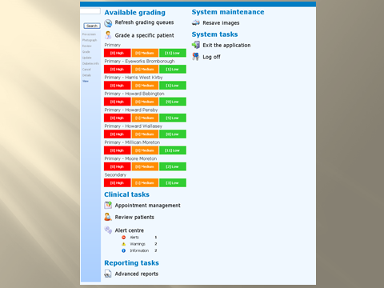
You will then see the following page and should click on ‘My intergrader agreement report’

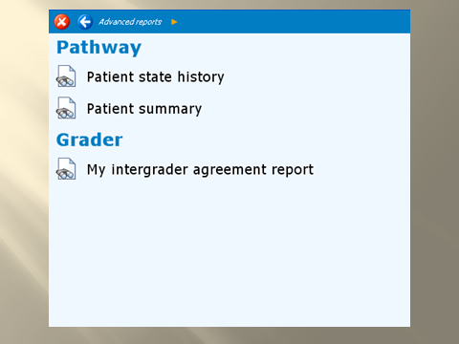

You should then select the period you wish to review, as shown below, and click ‘Run’
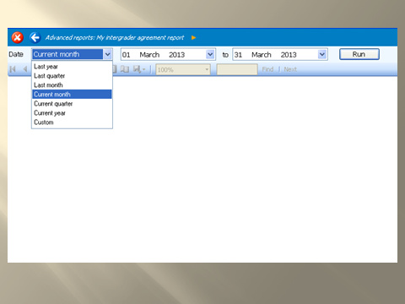

You will now see pages for either, Retinopathy, Maculopathy, or both as shown below.
The numbers outside the diagonal are disagreements that should be reviewed.

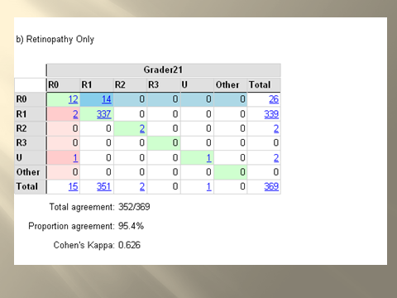

If you click on the numbers outside the diagonal, you will be shown a list of the disagreements.
Scroll along to the right and you will be able to click where it says ‘review’.
Please then study the images and decide whether you accept the disagreement. If it just a case of a ‘subtle’ ma or not, then there is no need to report it.

However, should you find anything that concerns you, please contact the optometric lead.
NOTE. Please do not just wait for our meeting. You should review regularly.

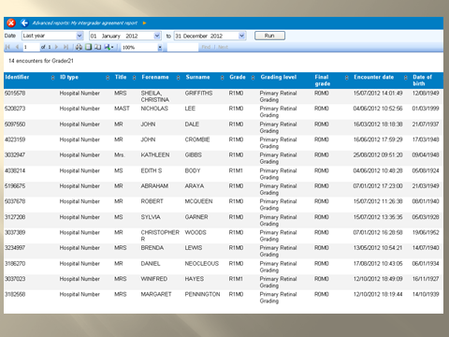
EQA test and training sets
You are aware that the national requirement for all graders is to do a minimum of
10 sets /annum.
Should any circumstances arise that prevent you from doing so, please inform the Optometric lead asap.

You are able to review any incorrect grades from the start of the following month.
We will also review grader performance at our small group meeting and would encourage the joint working with colleagues to continue during these reviews.

The Optometric lead has visited individual graders at their own premises should any assistance be required and is happy to do so.

EQA results are monitored every month. Remember that over grading or under grading cost marks.
Hence we mostly monitor missed R3’s or obvious M1’s.

NOTE; The NSC grading guidance images are available to view whilst on line doing the EQA tests.

21. Resources

Connection Problems

The correct procedure if you experience any problems is:

Contact Programme Managers as below

OptoMize Problems

The correct procedure if you experience any problems is:

Contact Programme Managers as below

Programme Managers/Failsafe Officers 604 7369

Pam Niccolls pam.niccolls@nhs.net 552 1895

Clinical Lead

Mr Abdul Gashut agashut@nhs.net

Lead Optometrist

Fred Howard

Email: fredhowardopt@gmail.com
fred.howard@nhs.net
Telephone 07581165356

Documents

All documents required for screening will be available to download on the
LOC website soon.

However please review the following

22. Internal QA and Equipment maintenance

It is the responsibility of the practice to ensure the security, maintenance and compliance of ALL equipment.

This includes IT systems, Camera’s, monitors and even the patient chairs.

Practice visits will be undertaken at by the lead Optometrist and/or programme managers.

The template for these visits is at the end of this document. NOTE, some areas of it may be altered as and when required.

A key requirement is evidence of regular maintenance of camera equipment.

The National committee may issue guidance that certain makes of equipment are no longer ‘fit for purpose’.

A regular audit of cameras will be undertaken and it would be useful for you to inform either the lead Optometrist or programme managers, whenever you update your equipment.

Consideration should be given to the suitability and stability of any chair a patient may use.
ie – could castors be dangerous? Are the hydraulics functioning correctly.

When purchasing such chairs it is advisable to ask what weight limit they are considered suitable for.

Such visits will usually be given 2/3 weeks notice.

_____________________________

23. Poor Performance Protocols

Wrong images.
Despite covering this issue on numerous occasions, it is disappointing that such incidents still occur.
The following protocol will therefore now be applied.

If a screener contacts the programme to report they have placed images on the wrong patient they will be issued with a ‘yellow card’ warning subject to a 12 month non repeat condition.

If they re-offend during the 12 months then a ‘red card’ will be issued with an immediate one week suspension or until further training has been completed.

If the error isn’t noticed at screening and it is only discovered by the programme at a later date, the ‘red card’ will be issued with an immediate one week suspension or until further training has been completed.
If a further incident occurs within 12 month a suspension for 2 weeks, will be issued.

All that is needed to prevent such incidents is to check the patients DOB

Please note. These protocols will be followed in ALL cases irrespective of volumes

Test & Training sets.

At our last joint meeting, you were provided with a summary of your performance. This showed the number of R3’s, R2’s, M1’s etc that were missed.
Some graders may have a similar overall average but missed far more serious retinopathy/maculopathy.

We have all reviewed these sets annually and the image manipulating tools have been improved.
Hence there now must be consequences for continued poor performance.

The Optometric Lead will highlight any concerns to the Clinical Lead and following a review the following protocol will be followed.

If a grader has missed a significant lesion that the Clinical Lead considers should have been identified, they will receive a ‘yellow card’ warning subject to a three month non repeat condition.

If they re-offend during the three months then a ‘red card’ will be issued with an immediate one month grading suspension or until further training has been completed. This applies to ALL grading !

If they miss further such lesions during the following twelve months a ‘red card’ will again be issued with an immediate two month suspension or until further training has been completed.

Graders should be reviewing their own performance month by month. Further small group review meetings will continue to be held although the Lead Optometrist will arrange one to one meetings if requested.
Please review the grading guidance previously issued.

Quick Update

As discussed and stressed previously, this is not OPTIONAL.
This is a requirement for our Health Inequality obligations.

Repeated failure to use this feature will be discussed at Board level with our Public Health colleagues.

Appointments
An extract from section 5 (please read full section) is as follows.

Once the patient has contacted the screening venue, the appointment MUST be made in OptoMize within 48 hours,(72 if over weekend) unless this is not possible. If it isn’t possible, this should be flagged up to the screening office and the reasons must be clearly reported, - -

Due to regular incidents of patients reporting they had already made appointments yet received further letters, the Yellow and Red card system will now also be applied to this requirement.

If a patient reports they had received a further letter, the programme manager will ask the patient the date they made their appointment. They will investigate whether there was a breach of the 48 hours requirement and if no reasonable explanation had been reported, a Yellow card will be issued.

A second such incident within 3 months will result in a Red card. At this point the practice will be suspended from screening for one month.
A further breach within 6 months will receive a suspension of 2 months.

Further repeats of such incidents will be discussed at Board level with our Public Health colleagues.

This screen has several more drop-down boxes for demographic information.

Please complete as many as possible.

Quick Update Screen

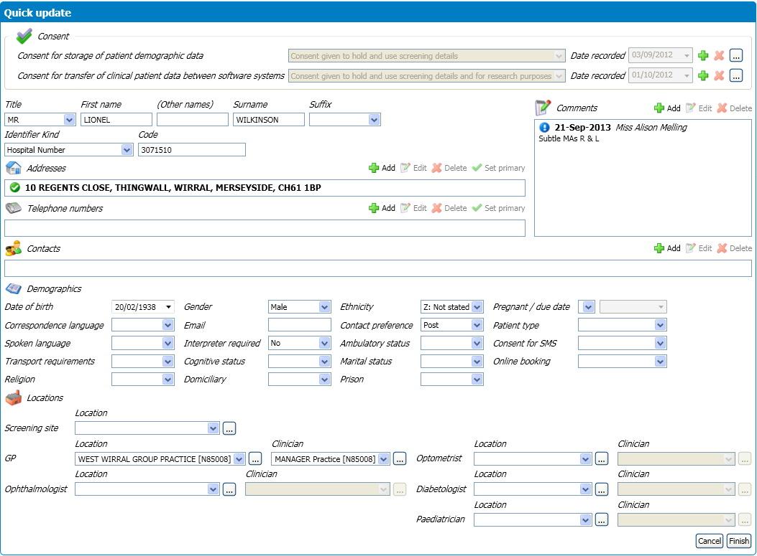
JAMES
JONES
987654
1 ACACIA GROVE, Some Town, , MERSEYSIDE, CH12345B
21-Jun-1950
THE CHURCHES [N123456]
[N123456]
Miss Amanda Mulling

