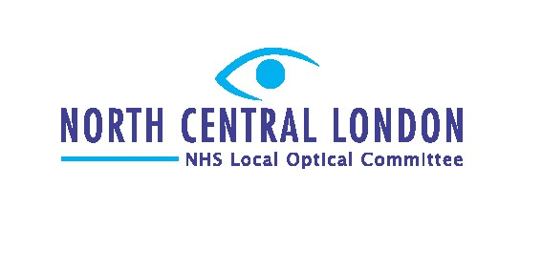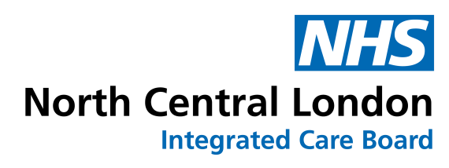

*June 2023 North Central London (NCL) Referral Pathway Update*

On behalf of all NCL NHS provider Trusts, we are writing to update you on the forthcoming availability of an alternative NHS referral pathway, for ALL NCL community optometrists

From 1st July 2023, a new pathway will be available to receive and process NHS referrals from primary care.

This new pathway allows referrals to be sent directly, via email, to a new NCL Single Point of Access (SPoA), hosted by Moorfields Eye Hospital on behalf of Royal Free Hospital, North Middlesex Hospital, Whittington Hospital, and Moorfields Eye Hospital.

The new pathway is designed to:

* Improve the efficiency of referral processing.
* Reduce patient journey time from point of referral to ophthalmology appointment; o Facilitate the launch of an advice and guidance service in the near future; o Facilitate the provision of continuing professional development-approved education to community optometrists.
* Embed processes to provide you with updates about your patients, including referral feedback.

How will it work?

The new Single Point of Access will:

* Check and confirm receipt of your referral, including any supporting documentation (N.B. you will have the option to attach images or other supporting documents, although you’re not obliged to as part of a GOS18 referral).
* Upload this information onto the electronic referral system (eRS) (as currently performed by the GP), for onward referral to local ophthalmology services.

When and how can I access this new pathway?

From 1st July 2023, emails should be referred to a designated NCL SPoA inbox. Will be in touch within the next 2 weeks with comprehensive details and guidance on how to use the new pathway.

How do I ensure the referral information complies with information governance requirements and remains secure and safe?

Please send your referrals from your [nhs.net](https://gbr01.safelinks.protection.outlook.com/?url=http%3A%2F%2Fnhs.net%2F&data=05%7C01%7Cdavid.graham10%40nhs.net%7Cc675ebd3fb1246d4043908db6e690168%7C37c354b285b047f5b22207b48d774ee3%7C0%7C0%7C638225169490726974%7CUnknown%7CTWFpbGZsb3d8eyJWIjoiMC4wLjAwMDAiLCJQIjoiV2luMzIiLCJBTiI6Ik1haWwiLCJXVCI6Mn0%3D%7C3000%7C%7C%7C&sdata=Cy%2B4F5byhOw9D1K04Pe4L1Zu1Sr9vTrhx9nyErgZPMc%3D&reserved=0) email account o Please note that unused NHS net email accounts may have been deactivated, so test this as soon as possible

* You can reactivate your account by getting in touch with helpdesk@nhs.net
* Please send us an email at to eyeadmin.ncl@nhs.net to confirm that your [nhs.net](https://gbr01.safelinks.protection.outlook.com/?url=http%3A%2F%2Fnhs.net%2F&data=05%7C01%7Cdavid.graham10%40nhs.net%7Cc675ebd3fb1246d4043908db6e690168%7C37c354b285b047f5b22207b48d774ee3%7C0%7C0%7C638225169490726974%7CUnknown%7CTWFpbGZsb3d8eyJWIjoiMC4wLjAwMDAiLCJQIjoiV2luMzIiLCJBTiI6Ik1haWwiLCJXVCI6Mn0%3D%7C3000%7C%7C%7C&sdata=Cy%2B4F5byhOw9D1K04Pe4L1Zu1Sr9vTrhx9nyErgZPMc%3D&reserved=0) address is active



I don’t have an [nhs.net](https://gbr01.safelinks.protection.outlook.com/?url=http%3A%2F%2Fnhs.net%2F&data=05%7C01%7Cdavid.graham10%40nhs.net%7Cc675ebd3fb1246d4043908db6e690168%7C37c354b285b047f5b22207b48d774ee3%7C0%7C0%7C638225169490726974%7CUnknown%7CTWFpbGZsb3d8eyJWIjoiMC4wLjAwMDAiLCJQIjoiV2luMzIiLCJBTiI6Ik1haWwiLCJXVCI6Mn0%3D%7C3000%7C%7C%7C&sdata=Cy%2B4F5byhOw9D1K04Pe4L1Zu1Sr9vTrhx9nyErgZPMc%3D&reserved=0) mail account: What is the process for setting one up?

o For Optometrists working at independent practices + small groups comprising less than 10 practices: Please use the NHS England sign-up portal at: [https://support.nhs.net/knowledgebase/registering-optometrists/](https://gbr01.safelinks.protection.outlook.com/?url=https%3A%2F%2Fsupport.nhs.net%2Fknowledge-base%2Fregistering-optometrists%2F&data=05%7C01%7Cdavid.graham10%40nhs.net%7Cc675ebd3fb1246d4043908db6e690168%7C37c354b285b047f5b22207b48d774ee3%7C0%7C0%7C638225169490726974%7CUnknown%7CTWFpbGZsb3d8eyJWIjoiMC4wLjAwMDAiLCJQIjoiV2luMzIiLCJBTiI6Ik1haWwiLCJXVCI6Mn0%3D%7C3000%7C%7C%7C&sdata=9cwNaZRr7xEtJu%2BofGqeVfd21DrMgpoz8g0QRLpgF3Q%3D&reserved=0)

o For Optometrists working at larger multiples comprising of more than 10 practices: Discussions are ongoing regarding how NHS mail accounts will be set up and we will update you in due course.

Any questions?

Please contact eyeadmin.ncl@nhs.net

Please note that this is for administrative queries only - please do not use this inbox for referrals.

NB: For information about updates to the eVonnect GOS18 pathway and continuation of the eVonnect paid pathways, please refer to our earlier communication (attached). We will continue to keep you updated about changes in the coming weeks.