Lincolnshire LOC AGM
10th July 2023

To be held virtually on Teams - 10th July 2023 @ 19.00

Agenda
- Chair’s welcome
- Apologies for absence
- Minutes of previous AGM
- Matters arising from previous minutes
- Chair’s report
- Treasurer’s report
- Adoption of reports
- Confirmation of adoption of new Model Constitution
- Appointment of Returning Officer and two scrutineers
- Election of the new committee
- Elected Chair’s address
- Adoption of the statutory levy including LOCSU Levy for the coming financial year
- Appointment of the Auditors for the forthcoming financial year
- PES update report
- Any Other Business

Attendees

Annabelle Magee
Manjeet Burgess
Samantha Oliver
Deepal Burgess
Adrian Cobb
Hayley Morrison
Lynsey Doherty
Angela Henderson
Martin Jago
Laura Tope
Amit Patel
Sab Bahl
Andrew Byrne
Stanley Mwamuka
Nizz Sabir (later arrival)
Tushar Majithia (later arrival)
Jason Rickaby (later arrival)
19.06 start

Chairs Welcome
AM: Completion of inaugural year, last year there was a rearrangement of the committee, we lost the core of the LOC due to going non-GOS – however we gained lots of new members and had a great year. We have set up a website and Facebook Page where we aim to put up to date information and there are links to the minutes for ease of access; email address on their for comms – any queries or questions to email and will get back asap.
Facebook: Lincolnshire LOC | Lincoln | Facebook
Website: loc-online.co.uk/lincolnshire-loc/
AM welcomes all attendees to introduce themselves.
- Annabelle Magee-Chair – Independent practice owner – contractor and performer
- Manjeet Burgess – LOC treasurer - Boots Lincoln – performer
- Sam Oliver – LOC member – Specsavers Lincoln – performer
- Deepal Burgess – vice chair – EeRS lead – performer
- Adrian Cobb – LOC vice treasurer – Specsavers Sleaford – performer
- Hayley Morrison – contractor – manger Asda Lincoln
- Lynsey Doherty – performer – greenwood opticians
- Angela Henderson – optom clinical lead PES covering North down to Lincolnshire
- Martin Jago – project manager for ICB
- Laura Tope– LOC Maternity cover secretary / EeRS – Performer – Lunettes
- Amit Patel – LOC member – Specsavers Lincoln - Contractor
- Sab – clinical lead for LOC – performer – Dixons Opticians
- Andrew Byrne – advancement lead with LOCSU – eyecare program – was hospital mx – been at NOC last year - non optom
- Stanley Mwamuka – Optom Director – Specsavers Skegness and Louth – contractor and performer
- Nizz Sabir later arrival thus introduced by AM as LOCSU advisor
- Tushar Majithia later arrival thus introduced by AM – LOC member – Lunettes – contractor and performer
- Sarah Grant unable to attend thus introduced by AM – DO – clearview – performer
- Martin Smith unable to attend thus introduced by AM – private practice owner therefore is an advisor on the LOC

Apologies for absence
None

Minutes of previous AGM
Current members confirm last AGM minutes is a true reflection

Matters arising from previous minutes
None

Chair’s report
AM: Thank you to all members – have achieved and have a lot ongoing – been a huge year for LOC – hope it continues - to update anyone who isn’t LOC.

Integrated Primary Care Transition and Development Group
AC has representation at Integrated Primary Care Transition and Development Group at monthly meetings to discuss the transition of Primary Care following the change of delegation structure within the local NHS from CCG to ICB

Lincolnshire Eyecare Delivery Group
Meetings have been attended every 6 weeks to bring together HES, Optometrists, Community Providers, Commissioners and other relevant organisations to oversee the development and delivery of an Ophthalmology Strategy/Vision for the patients of Lincolnshire - important all optoms have a voice and as part of LOC – we will be continuing going forward as well

EeRS
EeRS is coming – rolling out too all to everybody – had stalled – had hoped for early adopted but issues around safety and governance have stalled it – rolling out in September so not that long ago – MJ confirms
https://cinapsissurvey.typeform.com/to/cNhCRPZ5 – demo of Cinapsis who will be providing EeRS – all optoms need to be getting a feel – DB and LT are the leads – any questions to get in touch with them – will set up separate meeting purely for EeRS which will be Q and A session – need to be making sure DSPT is up to date and current – DBs list shows some people still not up to date
Complex areas around Information Governance and Clinical Safety, combined with diary availability, has slowed down progress of some of our early adopters. Managers will need privacy notice adjustment – data protection protocol to sign – further info and guidance will be sent out but need DSPTs up to date which will be required in that.

Pre and post cataract pathway
Nothing yet but hopefully getting that sorted out

IP grant
SB has worked hard and got funding for COTATs practitioners to do IP – MJ worked on that too – thank you for being so successful

Paediatric Service
AM working on paediatric service – got a good relationship going now – will be coming and working on it for next year – nothing finalised – when we have finalised will communicate with you

FP10s
For current IPs in the community – being worked on by AM and LT

DMO Pathway
We did try get this going – we all did all the training etc but this hasn’t gone ahead unfortunately – MJ offers to update –
MJ – thankyou all getting everyone stepped up – error was that had to get authorisation – didn’t go through acute trust – went through ICB and that is nw trying to be revisited – an ask of GIRFT – requirement of GIRFT that this pathway is in place – just need to get ULHT to say yes
AM: Thank you to Nizz – he will no longer be our support – formal intro to andy who will be our locsu support going forward – NS we are very grateful for all work done behind the scenes over the years
At end of tonight will be setting up a formal LOCSU evening
AB: introduces himself – Nizz been with LOCSU for 10 years – known him in 3 previous roles
Moving forward I’m not an optom – different skill set that’s why advancement lead not optical lead – variety of skills and knowledge – living and breathing EeRS for the last year – lots to do with Paeds pathways – Bassett law as part of the work up there
Any problems to get in touch with feel free to get in touch (with AB)

Treasurer’s report
AM invites SB to present:
SB: internet banking now working- AC and MJ set up – in near future will be able to get the handover from sab for previous years
We have got the EeRS money in bank – waiting for upskilling from rural and coastal fund.
Paid locsu £22,779.44
Took statutory levy of £45,564.49 – half of that goes to LOCSU
Got £63825.20 in the bank – now bank charges for all cheques – charge for having account - £66.80
Expenses £15,051.63 – most of which is meetings that have been attended – lots have engaged in meetings, never had a year like it since joined in 1997
3 bank accounts – one purely for EeRS money so will come out of that account so can be kept separate – has to pay invoices out the current account and then back filling – will be seen next year
Using the third one for IP but again can only pay out of current account
MB and MS signed off balance sheet
MB won’t be able to be auditor as will be treasurer
NS joined – AM reiterated gratefulness and thanks as previously said l

Adoption of reports
Current LOC committee confirmed happy to adopt reports

Confirmation of adoption of new Model Constitution
Current LOC confirmed adopting new model constitution

Appointment of Returning Officer and two scrutineers
Treasurer will be MB and AC with TM and SB scrutineering

Election of the new committee
AM: Rather than deplete and 1/3rd stepping down would rather grow with how well we are doing so far. Stacey will be formally stepping down with beautiful baby albert – thanks Stacey – Tushar seconded in chat
Lynsey would like to be involved as non officer – maybe comms
Sarah will be our DO representative that Stacey was before as entitled to have voice as part of LOC
Any objections or anyone unhappy raise hand – nobody raised hands very keen to share work – as LT promoted to secretary – can someone be vice sec – LD and SO interested
SO: happy for Lynsey to take that
New committee therefore:
Annabelle Magee – Chair
Deepal Burgess - Vice Chair
Adrian Cobb - Treasurer
Manjeet Burgess - Treasurer
Laura Tope - Secretary
Lynsey Doherty - Vice Secretary
Sarah Grant
Sab Bahl
Tushar Majithia
Amit Patel
Chaz Uppal
Martin Smith - non gos provider but acting as advisor for private practices.
Samantha Oliver

Elected Chair’s address
AM: Thankyou – let’s carry on – as sab said been great what we are doing and want to continue with our new LOC including Lynsey and Sarah

Adoption of the statutory levy including LOCSU Levy for the coming financial year
AM: 0.5% to LOCSU no voluntary levy – is LOC happy to adopt
LOC happy to adopt levy

Appointment of the Auditors for the forthcoming financial year
AM: need to be independent – Martin (Smith) can no longer as advisor and MB cannot as now treasurer
Need two people happy to audit financial reports – Sab and Tushar

COTATS report
Slides presented by Martin Jago

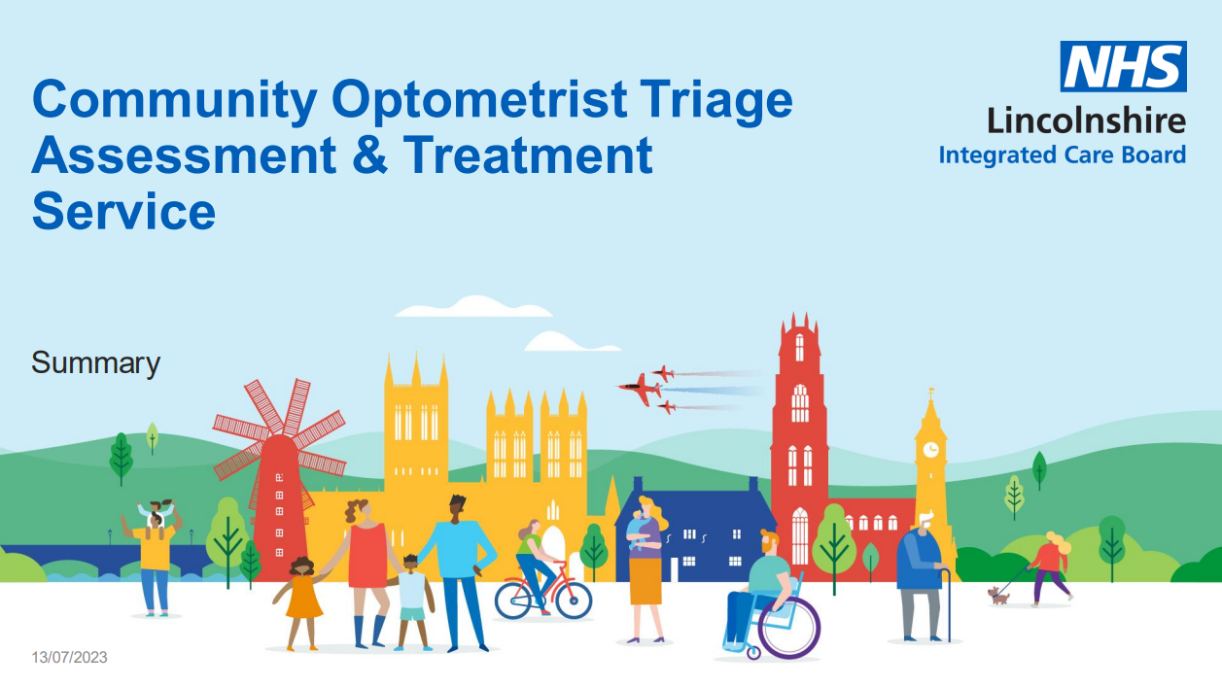
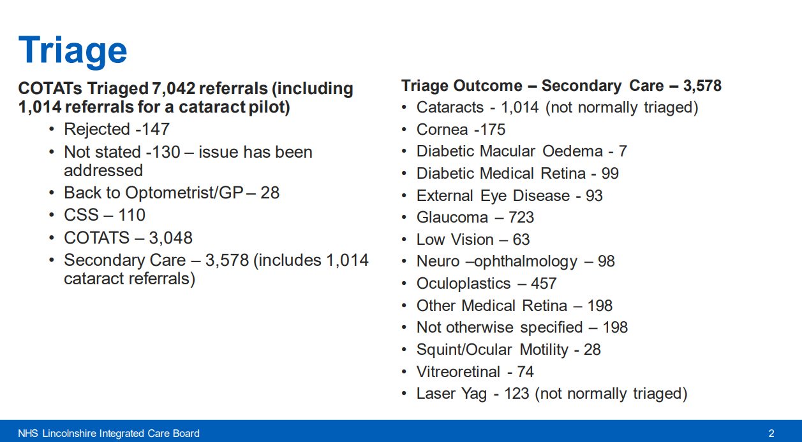
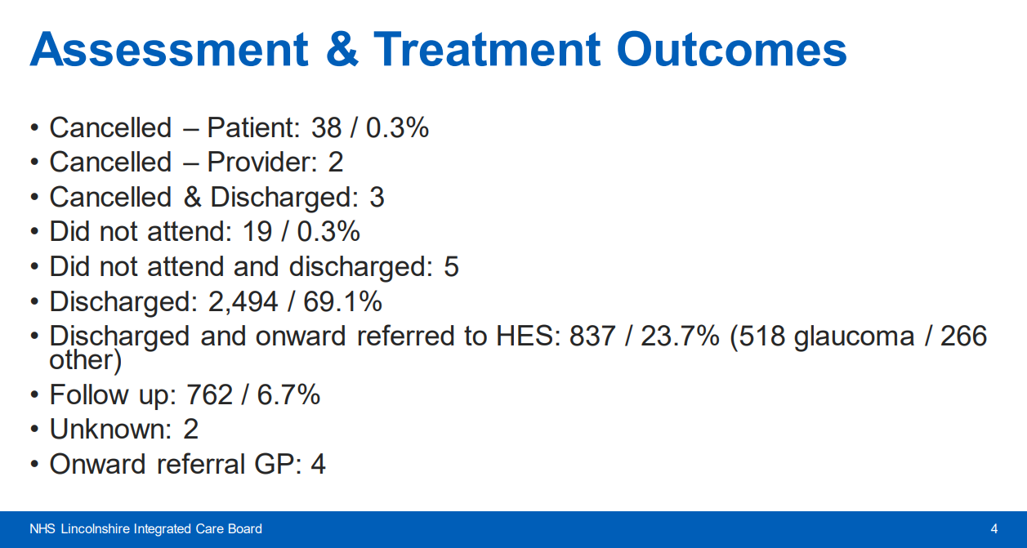

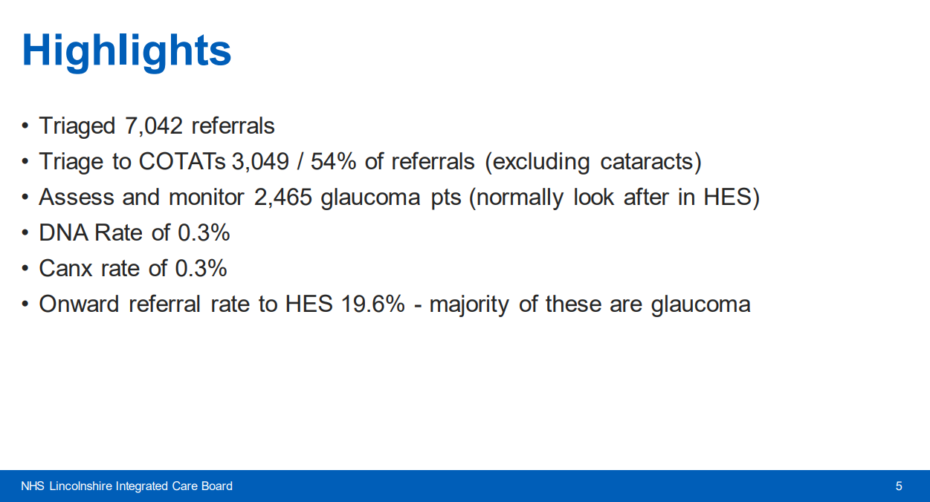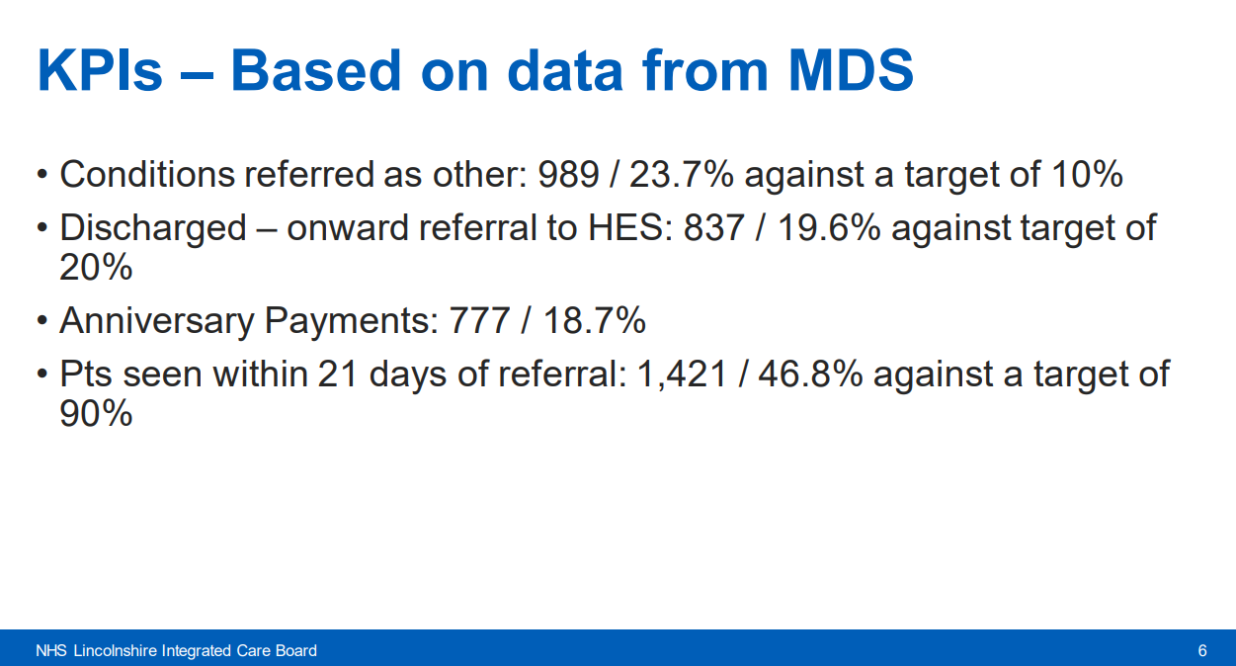
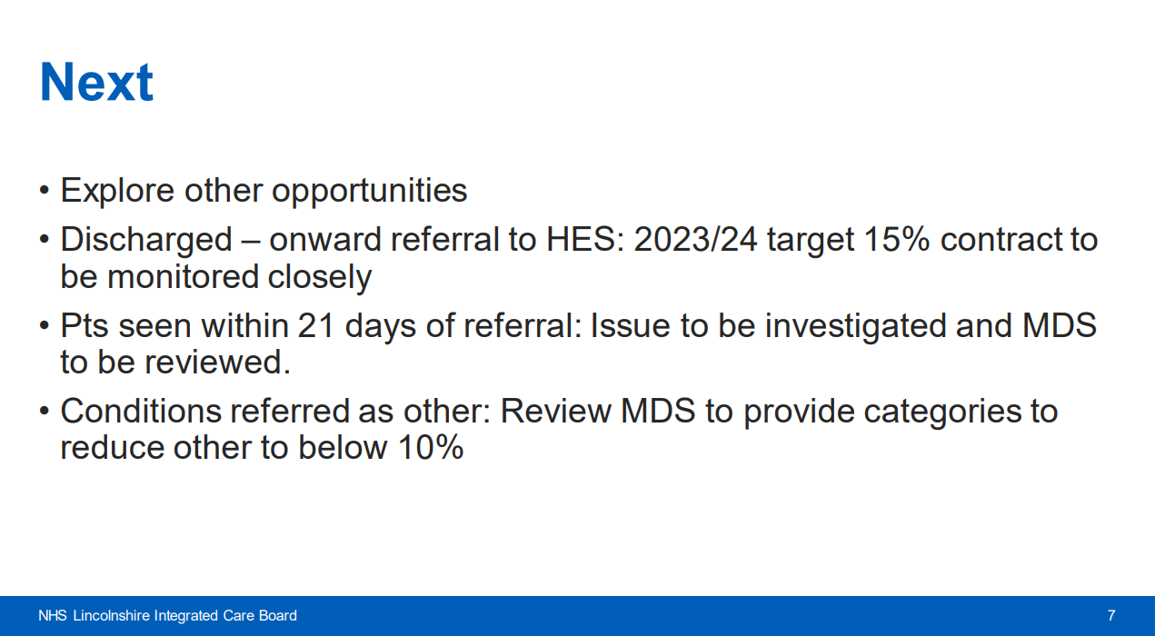
MJ: Need to work through IP and post op cataracts – reigniting the DMO pathway and the paediatric pathway. Invite questions
AM thinks all positive – would question high performing KPIs – questions the DNAs and the cancellations – are they being put on by providers
Sab : 3048 accepted cotats – then 2.5k assessment px – clarify please
MJ: New referrals are the 3048 – MDS shows 2.5k for glaucoma – new and anniversary – glaucoma ones - the rest of the referrals went straight to HES – slide pack shows triage / onward referrals
SB: other needs to be clarified – agrees with MJ
AB: Problem we have – lack of evidence it is successful – if LOC are happy then wants to discuss with MJ how the work is evaluated

PES company update/report
Presented by Angela Henderson
AH: Angela Henderson – clinical lead for PES - Optom based in Newcastle – lead service across north England down as far as Lincolnshire. PES is the largest single not for profit primary eye care lead provider in England – contracts with NHS commissioners and trusts to make NSH funded eyecare available from local practices.
PES holds 88 contracts across 29 ICBs in England. In 2022-2023 practictioners completed over 580k patient episodes. All service delivery uses OPERA which is secure and allows images transfer – developing integration with other IT platforms such as Medisoft. Services delivered includes:

- MECS
- CUES
- COTATS
- Pre/ post op cataract assessments
- Paeds
- LV
- Easy eyecare learning disability service
- Glau monitoring and refinement
- Medical Retina
- Single point of access - triage and telemed

AH: PES is the largest provider of COTATs across Lincolnshire; there is an MoU with the LOC to be the primary provider for PES to be the primary provider. PES working to support practices and practitioners to achieve COTATS accreditation; provide CPD and updates to PES providers of COTATS. PES works with commissioners and LOC to identify areas of service development.
Contact details:
Clinical queries: angela.henderson@primaryeyecare.co.uk
Contracting queries: hena.akhtar@primaryeyecare.co.uk
OPERA queries: hello@referral.support
AM: any queries
AH: lots of other on opera platform – so working with MJ to see how can improve reporting on the MDS
MJ: PES doesn’t have other but has list of lots of conditions – would be useful to have
AB: had discussion before – query is have we linked PES data to hospital data so when increase in activity in PES is there a corresponding reduction in HES care –
MJ – no as service been in place for 10-15 years so to get the direct impact would need the baseline when hasn’t got service – no ground zero to compare with – Jason been doing it 20 years –
MJ : we can see the impact by those going into COTATS not into hospital
NS: number of apt deflected by trust – more valuable to see impact over past 3-5 years
MJ: take glaucoma GIRFT – believed data was incorrect as discharged first time didn’t seem right - outlier on discharges form first apt
Sab: 17-18% of glau – discharged at first apt?? - clarifies the work done years ago – 70% of glau referrals discharged at first visit but ours is on 6% - that’s a good level of glau referring quality
AB: not got the baseline – compare to rest of country – still argument that having primary care services increases activity overall – level of activity in primary vs secondary care
MJ: whoever designed it were very clever – those who triage cannot refer to themselves – separate team books apt by px choice – which eradicates all ‘gaining’
AB: keen to champion optometry first
SB: are you aware of the issues with the consultant being unhappy about attachments
AH: Consultants not getting the attachment which is going with the opera referral – in hand – not to worry – EACH issue not the opera issue – comms has gone out to pes providers –w ill audit soon – process of going via each
MJ: Yes correct – hyperlinks not being attached – correct it is an EACH issue.

Any Other Business
None

Next Meeting
AM: Next one – Sunday 24th September – via teams – invites Andy – will do annual report
For current LOC – hoping to do paediatrics meeting – was proposed for weds 16th – will wait for confirmation – thanks for responses and will confirm
DB and LT to arrange EeRS meeting sorted for q and a before sept – upwards battle as not many non LOC on meeting – will put in minutes to get on board
MJ: EeRS – ICB now has Kelly – her role is to help us get the comms out for heavy engagement – got 2 months to prep all optical practices ready for launch in sept
SB: Reoffers help to LT and DB as previously said happy to
AM: thank you and close of meeting
Finish at 20.06

