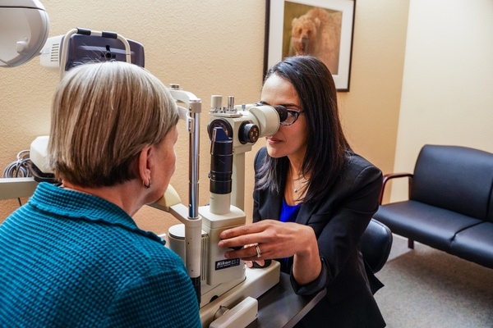

**ELECTRONIC EYECARE REFERRAL SERVICE (EeRS)**

**ISSUE 1: JANUARY 2023**

**Who is the provider?**

The METN state: “I am pleased to announce that the standstill period of the procurement process has now concluded, and I am able to share with you all that we have formally offered ***MonMedical*** the contract to provide the above-named service. (the system is Cinapsis)

This is subject to the relevant conditions precedent as set out in the Invitation to Tender contract, and successful conclusion of any remaining due diligence or assurance work.

We will be working with MonMedical over the next few days to formally agree and sign-off the contract for the Midlands EeRS service, and in parallel, MonMedical will be completing the Digital Technology Assessment Criteria (DTAC) process”

The contract target date to commence implementation of the service is 19th January 2023.

**What are the benefits?**

· Single EeRS for all to use

· Single referral template (by pathway)

· Attach all images (no limit)

· Linked to nhs spine

· Cloud based system

· Its free to users

· Links to EACH & COTATs

· Open up other service opportunities

### **In this issue:**

* What is EeRS?
* Who is the new provider?
* What are the benefits?
* What needs to be done?
* What is the ask from you?

# **What is EeRS?**

NHSE asked the 5 Regions to resolve the digital connectivity challenge between community optometrists and acute care bringing them into the nhs digital world. The Midlands Eyecare Transformation Network (METN) have been working with the 11 ICB’s over the last 18 months to procure a single Electronic Eyecare Referral Service (EeRS) for the Midlands.

The EeRS will provide a web based electronic referral service that will connect the optoms to the NHS electronic systems via the EACH and onto all providers of ophthalmology services.

A comprehensive specification was draft and an in depth and exhaustive procurement and evaluation was undertaken with a provider identified in December 2022.

**ICB**

· Martin Jago — Project Lead

· Paul Jibson — CSO Lead

· Sylvia Barcellona — Digital Lead

· Ben Johnson — Information Governance

· Alice Sheppard — EACH

**ULHT**

· Mark Sharman — Digital Lead

· Craig Leverett — BSU Manager

· Thomas Evans — CSO

· Stevie-Jo Williams — OPA

· Tracy Dunn — OPA

**LOCAL OPTICAL COMMITTEE**

· Deepal Burgess — Lead

· Chaz Uppal — Optometrist

· Samantha Widdeson — Optometrist

· Martin Smith - Optometrist non-GOS

· Laura Tope — LOC

· Sab Bahl — LOC Clinical Lead

**What is the Ask?**

**Lincolnshire EeRS Task and Finish Group:** Lincolnshire has an established Task and Finish Group with representatives from Local Optical Committee, ULHT and Integrated Care Board who will oversee the implementation of the EeRS across Lincolnshire. The group will need your engagement and co-operation:

**Clinical Safety**

Complete a full clinical risk assessment of the EeRS for Lincolnshire. Working with the Task and Finish Group Members a risk assessment has to be undertaken to identify the risk and issues of the proposed new system and the mitigation's

The areas focused on are

1. OPTICAL PRACTICES & OPTOMETRIST: What are the risk and issues for the opticians

2. EACH: What are the risks and issues for the EACH

3. ULHT / Providers: What are the risk and issues for organisations receiving referrals

**Information Governance**

Ensure all the appropriate information governance has been completed before implementation.

1. Data Protection Impact Assessment: to be completed by the ICB

2. Data Processing Agreements: To be completed by the ICB

3. Data Sharing Agreement: To be completed by the ICB and signed by optical practices

4. Data Protection Security Toolkit: All optical practices should have completed this as part of GOS. This needs to be up to date.

**Digital**

Working with optometrists and providers to implement the EeRS across Lincolnshire.

1. Work with the provider to implement / role out EeRS.

2. Work with LOC to agree most effective implementation plan for optometrists.

3. Ensure all digital elements are identified and addressed.

4. Support the training and education programmes and training modules supporting implementation.

**Timeframes:** The METN and provider have recommended that the EeRS has to be implemented by the end of March 2024 across 3 phases (please not this has not be agreed so may be subject to change):

· Phase One: Jan 23 — April 23

· Phase Two: April 23 — Aug 23

· **Phase Three: Aug 23 — Jan 24: Lincolnshire are planned for Phase 3 with work commencing now on making sure everything is in place prior to implementation and roll out**

THE CHALLENGES — to be addressed

1. Until the new system has been seen working, its ability remain unknown.

2. Interoperability:

· With optical practice systems

· With provider systems

· With EACH

3. 2 way communication: Will the HES be able to communicate directly with the optical practices and optometrists

**HOSPITAL EYE SERVICE**: