Lincolnshire LOC Meeting

September 2022

Held virtually via Teams on Monday 12th September at 19.30

Agenda
- Apologies
- Declarations of conflicts of interest
- Introductions to Martin Jago
-Any ongoing business (Martin Jago will then leave meeting)
- Update from EeRS meeting – DB/MS/CU/SO
- Update from regional forum – DB/MB
- Update from ICB primary care partners meeting – AC/SB
- Update from DMO - AC
- Update with contractor/meeting list - AM
- AOB
- PES to attend next meeting
- Date of next meeting – TBC as 17th October

Attendees

Adrian Cobb (AC)
Amit Patel (AP)
Deepal Burgess (DB)
Laura Tope (LT)
Annabelle Magee (AM)
Manjeet Burgess (MB)
Sab Bahl (SB)
Martin Jago (MJ)
Later arrivals: Tushar Majitha (TM), Chaz Uppal (CU), Martin Smith (MS)

Apologies
Samantha Oliver, Stacey Griffiths and Nizz Sabir

Declarations of conflicts of interest
None

Introductions to Martin Jago
AM: Independent practice owner, LOC chair, delivers COTATS with PES, Paediatric Clinical Lead
LT: Optom at independent in Lincoln, LOC comms
AC: Employed optom at Specsavers in Sleaford, met MJ at Primary care collab meeting, Medical Retina Clinical Lead
AP: Director / Optom at Specsavers in Lincoln, Primary Care Lead
MB: Optom at Boots in Lincoln, LOC treasurer, Cataracts Clinical Lead
SB: Independent practitioner, overall Clinical Lead, Optometric Advisor for NHS England
DB: Locum optometrist, LOC Vice Chair, eERS Lead
MJ: Planned care project manager for Lincolnshire, works with Ophthalmology, MSK and community pay
AM: Gives apologies on behalf of those not here.
SB: requests copy of agenda (LT to send)

Any ongoing business
AM invites MJ to talk
MJ: quick presentation for what is on the agenda for ophthalmology (to send slides to LT for sharing – included in minutes – property of Martin Jago)
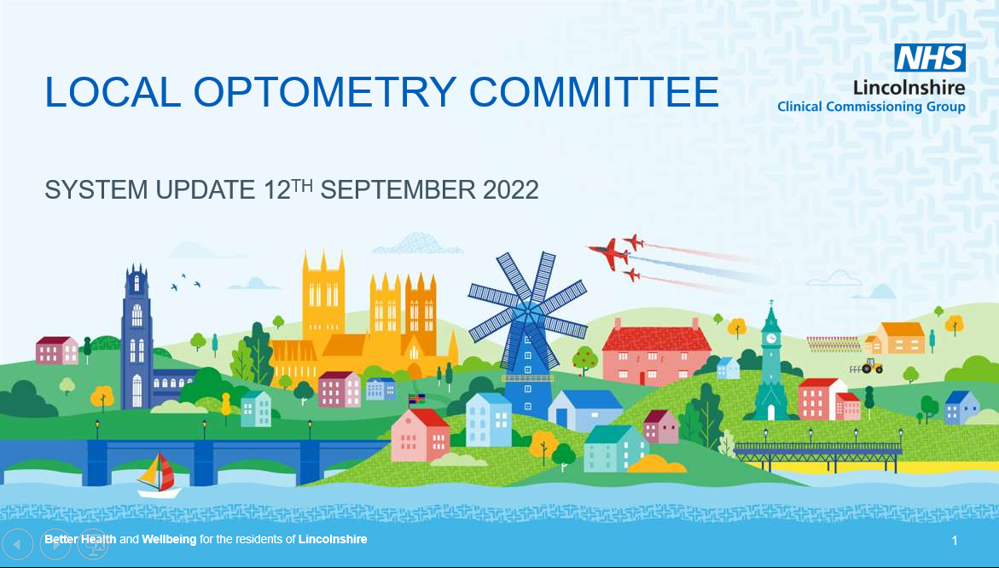
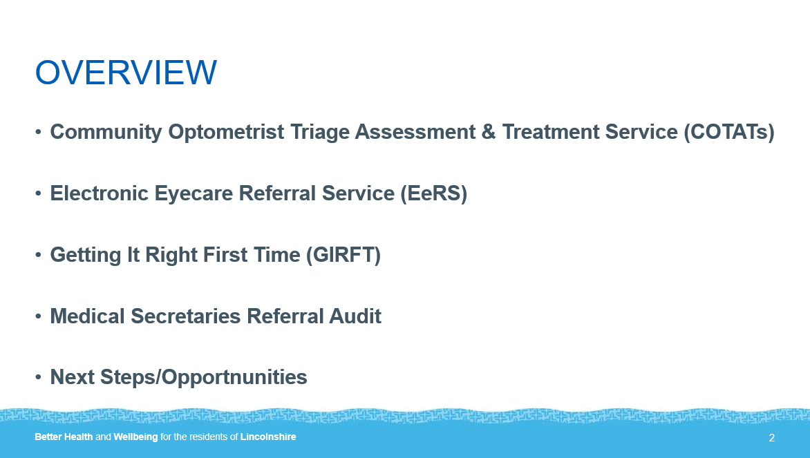
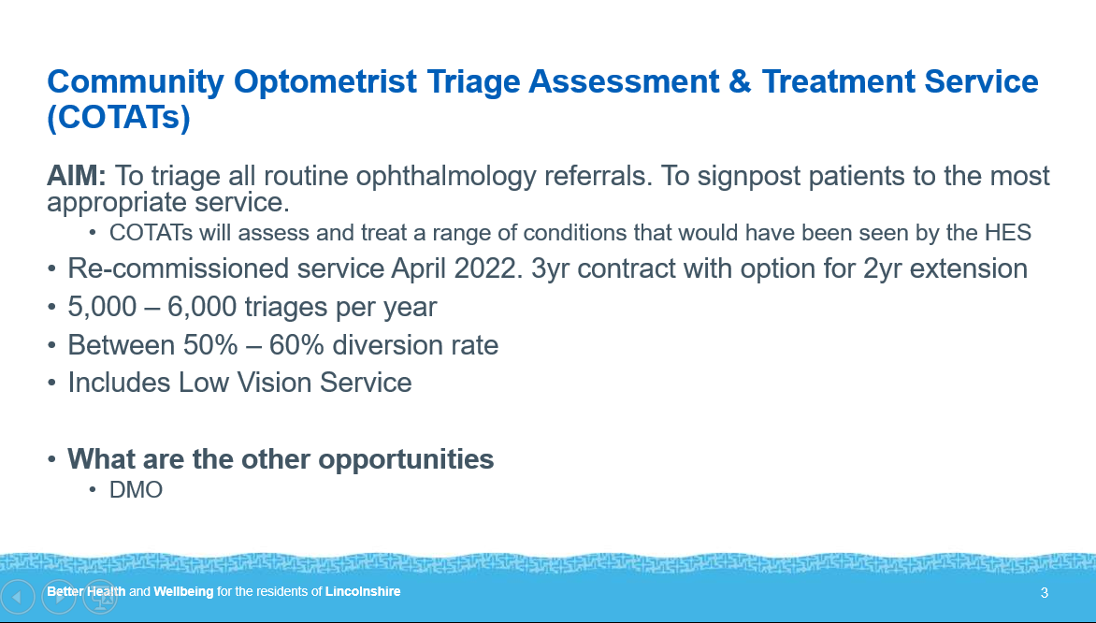
MJ: Lincolnshire has had COTATs 12-13 years so have been ahead of the game.
The 3 year contract and option for 2 year extension is for security.
The diversion rate now includes low vision which was brought in last year; currently working on a DMO diversion for pre-hospital OCT to be carried out – this will give the opportunity to expand and add – in other areas it gets positive feedback
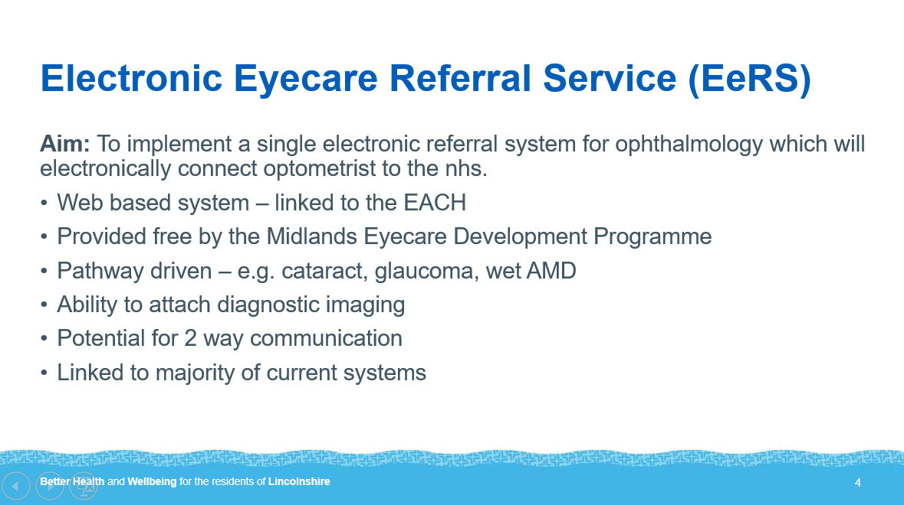
MJ: Each pathway would have an individual form rather than the generic GOS18
Will be integrated into systems such as those used by Specsavers – work is currently going on to ensure this goes smoothly.
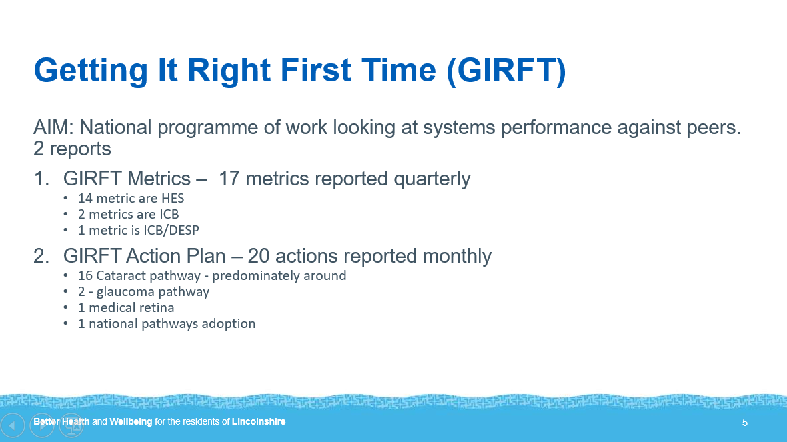
MJ: One example of the HES metrics are conversion rate for cataract surgery – risk stratification on referral
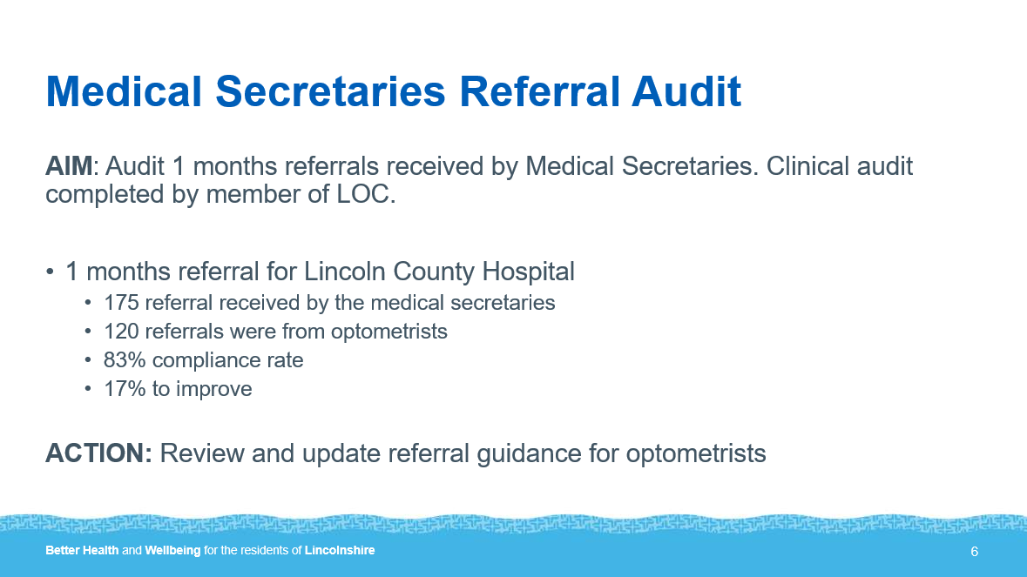
MJ: The results were reassuring but need to update guidance and redefine the definitions which seem to have got mixed with time, to be clearer what is routine / urgent/ emergency. One point raised was the difficulty for optoms finding out what is happening with patients – hope to provide new phone numbers and emails. Will be shared once reviewed.
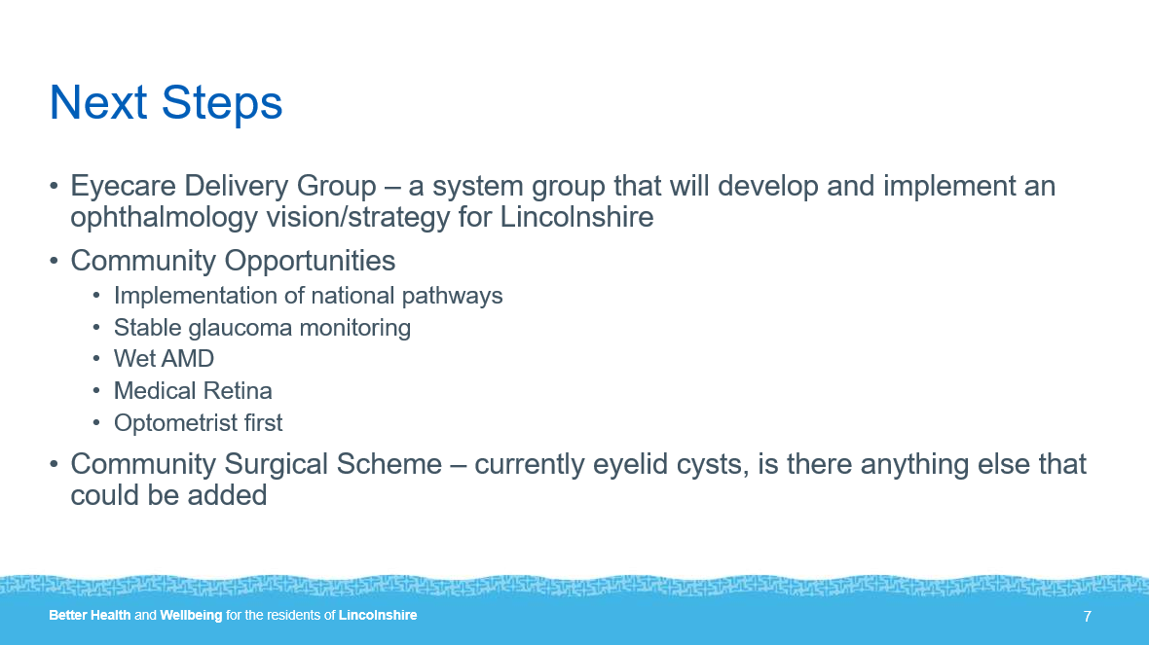

MJ: New clinical lead for ULHT – we have leaders in the community already. About half a dozen qualified optoms to do stable glaucoma monitoring. The management for wet ARMD will be a big point.
Optoms first – optoms have the skills and abilities to do things outside of an eye exam but pathways / funding required.
MS: raises that potentially cancerous lid lesions would need biopsy
MJ: reassures would not go to CSS
MS: idea of lash electrolysis
MB: punctum plugs
MJ: acknowledges ideas - if funding there
those with further ideas of what could be safely carried out to email jacqui.smith1@nhs.net
MB: agrees – takes longer than eye examination and would need equipment – remuneration issue needs to be negotiated
SB: we would need a really clear definition of what we are allowed to do – previously patient have got there and it is not an eyelid cyst so cannot be touched – must be lid cyst not conjunctival, not skin tags etc – if cysts end up in HES that would not be appropriate also.
MJ: will send up to date info

Follow up info provided:

Current narrative is:
3 OPHTHALMOLOGY
3.1 Eyelid cysts
• Chalazion and Meibomian cysts should initially be treated conservatively with 2 weeks of warm compresses applied four times a day. Surgery is reserved for cases not responsive to conservative management.
• Hordeolum (eyelid stye) should be initially be treated conservatively with warm compresses applied four times a day for 2-3 days before considering incision
Indications:
Referral to CSS should only be made if the cyst has persisted for 12 months or longer and one or more of the following symptoms are demonstrated:
· Infection which is resistant to treatment AND/OR
· There is a sebaceous dysfunction AND/OR
· The cyst impedes vision as evidenced by reduced visual acuity (due to astigmatism) or visual field tests if causing a lid droop, or causing amblyopia in a child AND/OR
· Patient is suffering severe pain and discomfort.
AM: AOB?
AP: Referrals through OPERA need attention – urgent referrals go through routine route so having to do work twice and send separately to ophthalmology secretaries.
SB: hold on that until the new emails in place – MJ sorting a new table which is being looked at so same info can be given to everyone and not have to be changes in a few weeks. Optom to carry on sending so have ability to chase as linked with own email otherwise if not from own email then won’t be able to chase.
MJ: yes – operation issues – old emails are incorrect – cleaning it all up so one point of information to share
AM: agrees with AP – his issue has been raised before and nothing was done about it over 6 months.
MJ: will have the conversation – which he has – informed Angela of new email which should be on OPERA as default.
SB: will have dedicated email for urgent – need to make sure form will be correct especially for locums
MB: queries time grame for receiving the info regarding new email / phone details
MJ: meeting tomorrow which will be shared with our LOC – once signed off and clinical lead happy will be shared widely but having to be picky over details.
SB: agrees – currently two different numbers for same thing – need to make sure when optoms are phoning that calls are answered. Raises issue about Spa Medica and AMD
MJ: not aware of contract in place and awaiting confirmation, ULHT has contract to transfer their referrals received to Spa Medica but no direct pathway – he has asked manager and is waiting on response
AC: needs to be cleared up with Spa Medica
AM + TM – email with info received with head of contracts CC’d in for one stop tx
MJ + SB: discussion regarding the lack of tracking if there is no pathway in place so would not know the numner of patients going directly to Spa Medica as would lose the data.
CU: huge AMD backlog, has had patients chasing referrals
LT: do we resend referrals which have been sent to Spa Medica until this resolved
MJ: will clarify the situation first but in meantime send via HES
AM: thanks MJ for answering questions
(MJ updated LOC next day and there is a pathway in place – so to use it as emailed by Stacey week prior)
AM: AOB? (none)

(Martin Jago leaves meeting)

Update from EeRS meeting
AM: asks for eERS update – who went?
DB: SO went – not much to update, there is not much to update and the next meeting is last Thursday in September (29th)
AM: next meeting to see if any update from that (to add to next agenda)

Update from regional forum
DB: main thing was voting in sometime called Charles from Birmingham who will represent the whole region of the Midlands at big meetings
SB: Charles Barlow – maybe?
DB: sounds right – he’s the official lead – at the meeting there was questions of his funding – the vote was to continue paying him to the Birmingham LOC normally but to split the funding between all LOCs for when he represents the midlands in larger meetings – 9 a year
AM: how do we feel about that?
MB: we don’t know what he will be doing and how much the fees will be - if beneficial to us then yes to split the bill but the role needs to be functional.
DB: he seems knowledgeable and he spoke to most – he has a good reputation amongst colleagues at the meeting – he would be backed up by a deputy too which would be funded by their own LOC
MB: requests clarification on role of regional forum
DB: to get the whole region on board – gives a seat at the table of the big conversation – gives info of what neighbouring areas are doing – NHS England attends
MB: queries regional forum vs NOC
CU: regional forum is regular. Are we voting if we are going to fund the place?
MB/AM: how we all feel – any other?
SB: not been part of regional forum – with ERS midlands decided to roll it out with the NHS – Lincolnshire going to be part of – other regions going first to see how it goes in their areas. Charles Barlow (if is him) is a sensible chap
AM: sounds fair – if everyone agrees and happy to fund ok but requires more info long term (agreed by LOC) – these meetings are 3 monthly so to get clarification at the next meeting (DB to action)
DB: how much and how split is to be decided
CU: it sounds open as other LOC going and collective so what happens will be reported back – sounds like if he knows what he’s doing makes sense to fund.
AM: we have COTATs so may not be relevant to us what he is negotiating
Discussion about how many meetings vs how many LOCs – to be clarified by DB at next regional forum and relayed back to us.

Update from ICB primary care partners meeting
AC: lots of form filling and prep for the change over next April
SB: meeting with pharmacy / optometry / dental and GP – the primary care transition oversight group – what will change when transitioned to ICB . Sandra Williamson said about local funding rather than from GOS 18 and talked about the governance, leadership and finance
AC: agrees
AM: AC /SB to keep posted
AC: signed a letter put together on behalf of committee – breakdown by the ICB board – though was not a clear picture of pf what was to be represented on board – collaborative letter sent through asking for an idea of primary care will do / primary care to have voice at the table
MB: when is next meeting?
AC: First Wednesday of every month (5th October)
MB: when is the next forum?
DB: 6th December

Update from DMO
AM: and about the DMO email – expressions of interest?
AC: got an email from MJ which was forwards – accreditation and what numbers will be coming through as an estimate between providers. Email went out over a week ago for the expression of interest – initially just COTATs - still outstanding questions about the level of accreditation required, when decided would need an accreditiation CET event before providing it – believes communication will be coming shortly as the scheme believed to be starting end of October
DB: VA and images – no accreditation needed for that?
SB: if you see something that needs referring would be sticky situation to just stick to doing VA and images
TM: accreditation with Paul Tesha, clinical lead, initially there will be a lot of auditing to ensure appropriate management – not long now so things are moving.
DB: agrees should be accreditation
AC: PES email made it sound simplistic just taking VA / image and send but more likely when someone seen by DRS if there is a query about if DMO then OCT to see if DMO or other condition; what is up in the air is when we look at images and decide on pathway – DMO or AMD clinic – the training for that needs to be made clear
SB: if we are doing VA and not our patient how do we know if that level is normal for them or not – need patient to wear the right glasses too. Regarding the number – confusion of what they are sending – not just DMO – 750 to 1000 are ungradable even when dilated, when we see in practice will still be ungradable but OCT will tell if DMO or not but the photo won’t be any clearer. That number at the moment are dilated and VOLK’ed by ULHT.
AC: just rechecked email – confusing – it says grading by DESP before referral
SB: sent to hospital as ungradable – can’t decide if DMO until had OCT – they don’t want to be in the hospital as some are normal
AC: took questions to MJ which he forwarded – Angela Henderson raised issue of it not going through her
SB: not to let things be rushed through
AM: when spoke to MJ pre all this – presumption med ret would cover DMO – are you happy to AC
AC: agrees but issue of emailing the right person – MJ will invite AC to all meetings relating to the DMO pathway – sounds like moving fast – will compose email of collective LOC questions (AC to action)
AM: MJ guided by what we advise as clinicians – PES is a separate thing to COTATs and the LOC is a separate thing again – encourages AC and what we do locally is very good PES is national
AM: Angela wants to attend our next meeting – wants to know who clinical leads are and then can leave – discuss the problem AP raised with the emails and LOC vs COTATs vs PES – are we happy for that
TM: good idea for Angela to attend – get assurance that people will be accredited and are adequate to carry out role – going back to DMO just posted a flow chart to Whatsapp group of what happens with ungradable vs suspect DMO which Martin sent out to all COTATs providers
SB: seen it – draft pathway is national pathway for DMO – hospitals have OCT done as they don’t want to have to do it in hospital hence COTATs – the scheme is because OCT should be done preclinic – will get clarification regarding the top of the flowchart and come back to us at next meeting (SB to action)
AM: wraps up

Next Meeting
AM: 17th October
DB: just after NOC (NOC on agenda)
(PES attending as discussed previously)

Update with contractor/meeting list
AM: contact email for all contractors
LT: getting there – working from old lists – have the list of practices from SB – telephone not email
AM: got all LOC people on the list – can try to add and take off list at meetings / CPD to keep up to date
CU: requirement for LOC to have for AGM notification
LT: have email list passed on - of practitioners but that not the contractors necessarily
AC: should be a practice mailing list so we can inform all practices that pay levy and update them on things like the Spa Medica issue – need some way of getting practice emails
MS: ask EACH / OTG as they will have the emails used by practices for referrals
CU: doesn’t the treasurer have the list of those that pay levy
AM: LT / MB to sort out email list based on those who pay in (LT to action)
AC/ CU: agrees then covered all

AOB
AM: Whatsapp group numbers – whos who
LT: Number read out by AM should be Lincs Opticians not LOC – to remove and SB to reallocate
AM: still things such as auditing referrals etc we need to be aware of – let’s keep more abreast of things
DB: is anyone going to NOC?
AM: Sab / Tushar
AM: wraps up – closes meeting – thanks everyone

End: approx. 21:10

