# **NHS Hampshire and Isle of Wight Cataract SPoA:**

# **Referral instructions for Optometrists**

## **Table of contents**

Table of contents

Introduction to Cataract Single Point of Access (SPoA)

Referral flow chart

Step-by-step instructions

Step 1: Assess if the patient is suitable for the NHS cataract SPoA

The Cataract SPoA should be used for patients:

Step 2: Assess if the patient is suitable for autonomous phone call (Dora)

Assessing if patient is suitable for autonomous phone call

Step 3: Tell the patient to expect a call from the SPoA and provide information where to access the leaflet

Step 4: Prepare GOS18 referral form (if the patient is suitable for a call)

Step 5: Email referral to hiow@spoa.uk using NHS.net email or secure email e.g. Egress

Step 6: Confirm receipt that Dora call has been scheduled

Step 7: If the patient is unreachable by the SPoA service

Contact information

Appendices

Appendix 1: Leaflet for Optometrist to give to the patient

Appendix 2: Example text message that your patient will receive before the Dora call

## 

## 

## 

## 

## 

## 

## **Introduction to Cataract Single Point of Access (SPoA)**

NHS Hampshire & Isle of Wight Integrated Care Board (ICB) has successfully obtained funding as part of the NHSE Eyecare Accelerator programme to launch a Single Point of Access (SPoA) for cataract patients in the region.

The aim of the SPoA is to streamline all NHS cataract referrals to one point & offer patients full choice of providers in a standardised scalable way.

When launched, Optometrists will refer all NHS cataract patients directly to the SPoA by email. The SPoA will then call patients using an autonomous system to offer them choice of surgical provider, ordered by travel distance from home postcode or waiting list times. Once the patient has chosen, the SPoA will send the referral to the patient’s chosen provider by eRS. Referrals will not have to go via patients or customers’ respective GPs.

The ICB has partnered with a company called Ufonia to manage the referrals in the cataract SPoA, and to call the patients to discuss choice of surgical provider. Ufonia is an autonomous telemedicine company that conducts clinical conversations with patients over the telephone in plain English using an autonomous system named "*Dora*". Ufonia has already deployed "*Dora*" to call patients at various points in the cataract pathway across multiple trusts in the Southeast, and within NHS Hampshire and Isle of Wight, have ongoing work with PHU & UHS.

The referral process for the Cataract SPoA requires little change for the referring optometrist to existing processes and in many cases simplifies the current process. For most cataract patients who qualify for the autonomous call, the discussion regarding which provider they would prefer can be skipped. Instead of sending referrals through multiple channels via different GPs or Primary Eyecare Services, all NHS cataract referrals will now be sent to one email address for the cataract SPoA. The process is detailed and mapped out in the following pages.

## **Referral flow chart**

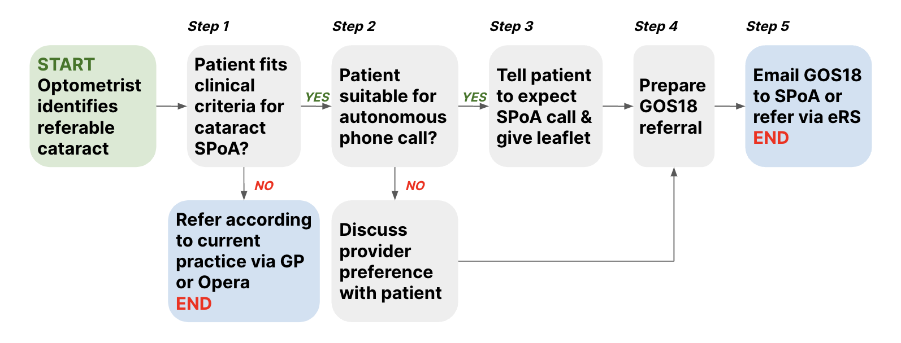

## **Step-by-step instructions**

### Step 1: Assess if the patient is suitable for the NHS cataract SPoA

* 1. If yes, proceed to step 2
  2. If no, refer patient according to current practice through GP or Opera

#### The Cataract SPoA should be used for patients:

* Aged 18 years and above
* Where cataract is present on clinical examination and most urgent ocular condition at the point of referral.
* Who have significant symptoms that limit vision related activity
* Who wishes to consider cataract surgery

### Step 2: Assess if the patient is suitable for autonomous phone call (*Dora)*

* 1. If yes, skip the discussion with the patient about where they can get their cataract treatment and proceed to step 3
  2. If no, have the choice conversation as per current practice, proceed to step 4, and **include the reason the patient was unsuitable along with patient or customer’s choice of provider in the GOS18 form and the email in step 5**

#### Assessing if patient is suitable for autonomous phone call

[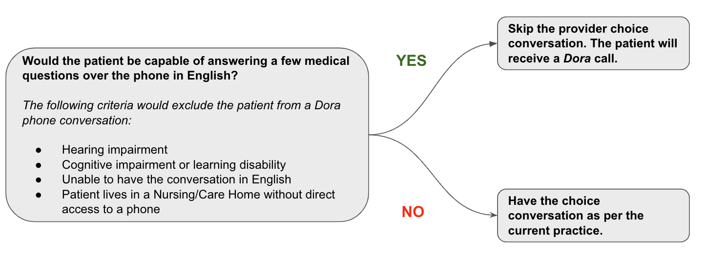](https://docs.google.com/presentation/d/1KIT9bAyKvqTKqHxkIku731IWe59SVbSH7F6rF8vjn4A/edit?usp=sharing)

### Step 3: Tell the patient to expect a call from the SPoA and provide information where to access the leaflet

* You can use this script to tell the patient what to expect:

“I’m going to refer you for cataract surgery. Because there are many places in the region where you can have NHS-funded treatment, they have arranged a phone call to discuss your options.

A smart digital assistant named “*Dora*” will call you on your mobile or landline to ask you a few questions, before discussing the different places you can get treatment. You can speak to *Dora* in plain English, just like you are speaking with me.”

* Patient information leaflet, see Appendix 1:
  + Promote digital information: The leaflet includes a QR code for easy digital access
  + Direct patients to the [ICB webpage](https://www.hantsiow.icb.nhs.uk/cataracts): the leaflet is also available online for patients with internet access.
  + Reserve printed leaflets: provide hard copies only for patients who lack digital access

### Step 4: Prepare GOS18 referral form (if the patient is suitable for a call)

1. Prepare the GOS18 referral form as per current practices
2. Please ensure the GOS18 form includes the following information:

It’s important that the following information reflects the details as recorded on

the patient’s GP record.

* + Title/salutation
  + First name
  + Last name
  + Gender
  + Post code
  + Telephone number(s), preferably mobile
  + Date of Birth
  + NHS Number (if known)

1. Save the GOS18 referral form as a **PDF** (*this is the only accepted document format*)
   * If the patient is unsuitable for a *Dora* call, please continue with the provider choice conversation in person. Indicate in writing on the GOS18 form and take the following step:
     + Subject of email: Cataract Referral - Unsuitable for Dora
     + Body of the email:
       - Reason why the patient is unsuitable for Dora as per the exclusion criteria:
         * Hearing impairment
         * Cognitive impairment or learning disability
         * Unable to have the conversation in English
         * Patient lives in a Nursing/Care Home without direct access to a phone
       - Patient’s preferred provider for cataract surgery as discussed

### Step 5: Email referral to [hiow@spoa.uk](mailto:hiow@spoa.uk) using NHS.net email or secure email e.g. Egress

1. When referring, attach the prepared PDF of the GOS18 form to the email
   * If at step 2, patient was assessed as unsuitable for autonomous phone call, please write the following on both the GOS18 form and the the email:
     + Subject of email: Cataract Referral - Unsuitable for Dora
     + Body of the email:
       - Reason why the patient is unsuitable for Dora as per the exclusion criteria:
         * Hearing impairment
         * Cognitive impairment or learning disability
         * Unable to have the conversation in English
         * Patient lives in a Nursing/Care Home without direct access to a phone
       - Patient’s preferred provider for cataract surgery as discussed
   * Please note that all emails to the SPoA service must have an attachment in order to be processed.
2. Send the email to [hiow@spoa.uk](mailto:hiow@spoa.uk)

* Please be advised while transferring patient data electronically, as per best practices we encourage the use of NHS.net email, or alternative forms of secure email (e.g. Egress)
* Please follow this link to setup an Egress account: <https://support.egress.com/s/article/How-to-create-an-Egress-account>

***If you have multiple patients to refer, please send a separate email for each referral. There should only be 1 patient referral per email.***

### Step 6: Confirm receipt that Dora call has been scheduled

1. The SPoa team will process the referral and schedule the Dora call
   1. You will receive an email to confirm the referral has been processed and the Dora call has been scheduled within 2 working days.
   2. If you have not received a confirmation please raise this via email using subject [awaiting confirmation].
2. The SPoa team is unable to process the referral and schedule the Dora call
   1. The inability to process referrals relates to the patient details provided
   2. The SpoA team will contact you via email requesting to check the patients details and resend the updated referral
      1. The SPoA team will add to the subject title of the email [ACTION REQUIRED]
      2. Confirm the patient details - making sure it reflects the GP records and resend the referral to the SPoA team
      3. If after 5 working days the SPoA team have not received the correct patient details, this will result in the referral being rejected.

### Step 7: If the patient is unreachable by the SPoA service

If the patient is unreachable by the SPoA service on all of the phone numbers provided on the GOS18 form, following multiple attempts over multiple days, the patient will be automatically referred to the closest NHS Provider.

## 

## Contact information

The [hiow@spoa.uk](mailto:hiow@spoa.uk) email is for referral contact only, once a referral has been confirmed and processed, please do not use it to ask follow up questions. If you have questions about the referral process in general or about a referral that has been processed, please contact

[hiowicb-hsi.cataractspoa@nhs.net](mailto:hiowicb-hsi.cataractspoa@nhs.net). This email address is also directly available to patients to answer any referral questions or provide support with the process.

If you have any questions about the programme, please contact [hiowicb-hsi.icbelectivecaremailbox@nhs.net](mailto:hiowicb-hsi.icbelectivecaremailbox@nhs.net)

## **Appendices**

### Appendix 1: Leaflet for Optometrist to give to the patient

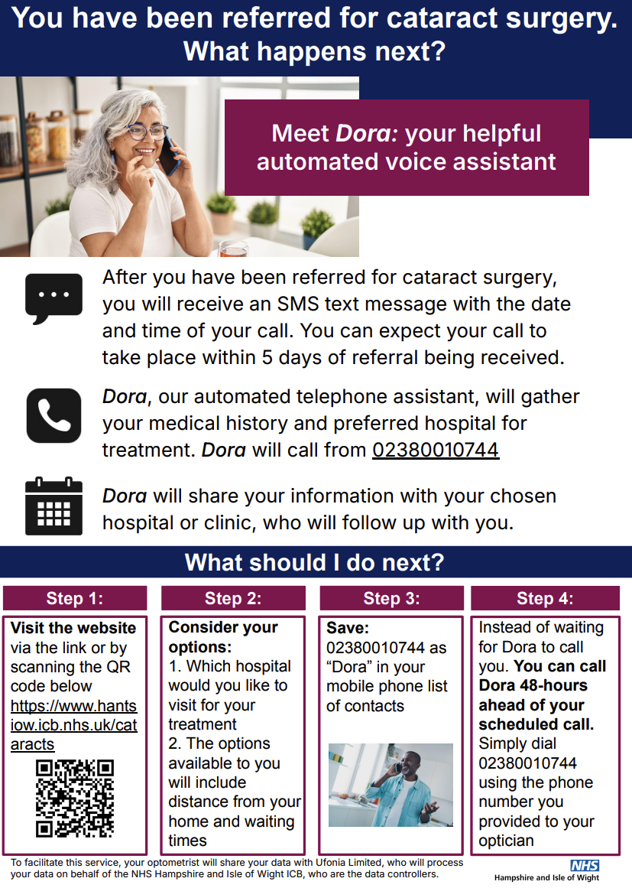

### 

### Appendix 2: Example text message that your patient will receive before the *Dora* call

Dear Mr John Smith,

You’ve just been referred for cataract surgery by your optometrist or GP. There are many places in the region where you can get treated. To help you choose, the NHS has arranged for our automated telephone assistant - called *Dora* - to ring you and speak to you.

We’ll ask you a few questions about your medical history to determine where you can be treated, and discuss your options. The call will take around 10 minutes. The details of your call will be passed to your care team ahead of your appointment.

Your call from *Dora* will be on:

Tuesday 19th December, 2023 at 4:35pm

from the number:

+44(0) 23800 10744

*Dora* will try to reach you on any phone numbers you have on the system.

Before the call, you can see a list of treatment providers in the region with links to their websites [here](https://www.hantsiowhealthandcare.org.uk/cataracts). Please note that depending on your overall health, not all of them may be suitable for you.

Thanks,

Hampshire & Isle of Wight Integrated Care System