West Hampshire Enhanced Referral Service
All Patients that have a West Hampshire GP who need a non-emergency eyecare referral will be triaged using the ICB commissioned Primary Eyecare Services (PES) triage hub. This hub is not for emergency referrals and existing local arrangements must be followed for such referrals. Referrals can be sent directly to the triage hub in below ways.
- Via nhs.net to cnech.pecservices@nhs.net
OR
- REFERRAL VIA OPERA (if you are signed up to deliver this service) routine-ophthalmology-clinic type-’West Hampshire hub referrals – GOS 18 only’, alternatively, the referral can be made as per the following steps.

- Add the patient onto OPERA by searching for them in the usual way. Once found. Click on the clipboard corresponding to ‘GOS18 eERS’

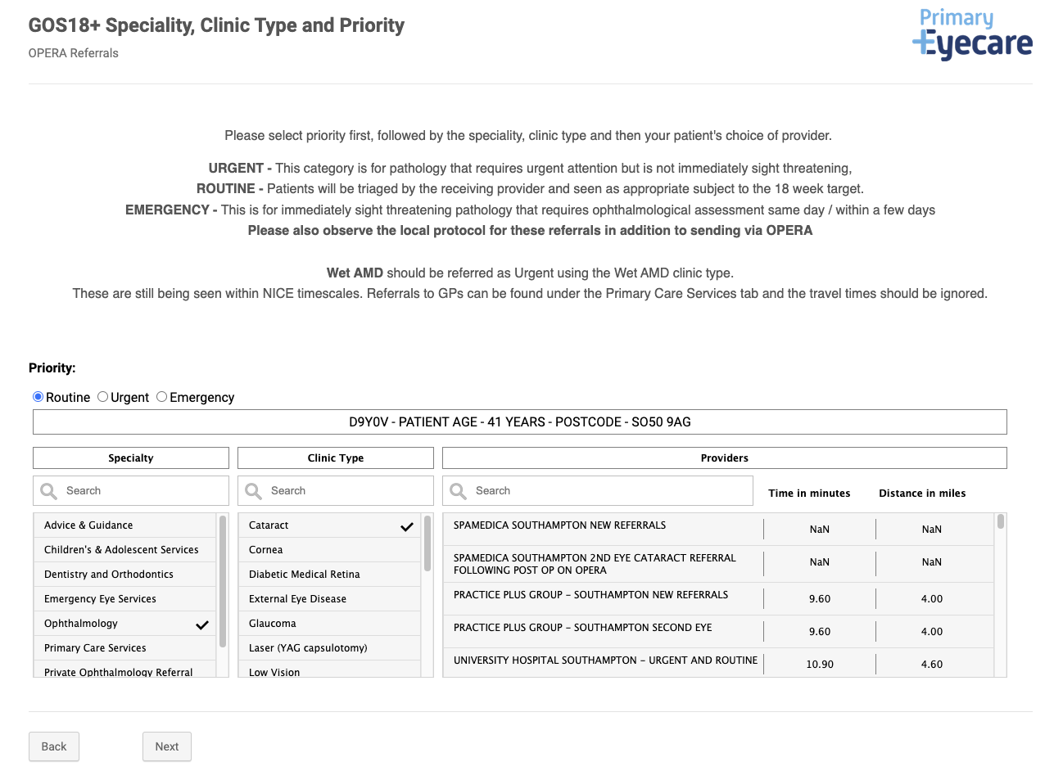
- Next, you should see the screen below. Select Priority Routine and then the subspeciality you wish to refer to In this case we will use cataract as an example.
- Select the provider you wish to refer the patient to. The provider list will be listed from nearest to most distance from the patient’s address.
- Continue to progress through OPERA until the referral is complete.
Any routine referrals that do not go via the above route to ophthalmology and that are sent to a GP will be forwarded to this triage service. Please support minimising GP time spent on unnecessary administration by NOT referring to the GP practice for routine ophthalmology referral.
Following referral, trained Optometrists at PES triage hub will do one of the following:
- Direct to an appropriate ophthalmology clinic
- Direct to an appropriate community service (GRR/GERS/CUES)
- Reject the referral back to the referrer for further action
This referral pathway has been commissioned locally and is mandated for all patients in the West-Hampshire GP catchment. The list of GP practices this pathway applies to can be found at the end of this document.
Referral Pathways for West-Hampshire Patients:
Referral Type | Pathway
Routine referral to GP | Direct to GP
Non-emergency referral for secondary care eyecare needs | Via PES Enhanced Referral Service
Urgent (for certain conditions e.g. AMD) or emergency referrals | Direct to required care provider

FAQ’s:
Q: I don’t have OPERA, do I still need to use this hub service?
A: This service has been commissioned as the local pathway to access non-emergency NHS secondary eyecare services. If you do not have OPERA, please email cnech.pecservices@nhs.net. You cannot bypass the hub to access non-emergency care.

Q: I don’t deliver any services for Primary Eyecare Services, would there be benefit to sign up for OPERA for referrals only?
A: Yes. OPERA allows you to upload images, including OCT scans, images and fields. You are able to select the hospital or clinic you wish to refer to from a list that is distance specific for the patient. Furthermore, you will get feedback on your referrals if needed and can see where the end outcome of the referral pathway is.

Q: Do I have to have an NHS.net email to refer via email to the triage hub?
Ideally yes. Patient data must be always secure and nhs.net emails are known to be encrypted to prevent the leaking of such data. Many hospitals often insist that referrals made should be via nhs.net emails but as there is a wide issue with access to these sorts of accounts, OPERA provides a safe, encrypted alternative to sending referrals regardless of whether the end clinic has access to OPERA or not.

Q: I don’t want the patient to use GRR/GERS as I feel it’s not needed and ophthalmology care is indicated. Can I bypass this triage journey?
A: No, the commissioners have determined that all suspect glaucoma patients must undergo community triage prior to accessing routine suspect glaucoma ophthalmology review.

Q: Do locum optometrists also have to use this system?
A: All optometrists referring for non-emergency NHS secondary care for a patient with a West-Hampshire GP must use this triage referral pathway.

Q: What are the local urgent and emergency referral pathways?
A: Up to date urgent and emergency referral pathway information can be found on the Hampshire LOC website.

West Hampshire GP Practices List:
EASTLEIGH NORTH | NEW FOREST | AVON VALLEY
St. Andrew’s Surgery | Wisteria & Milford | Fordingbridge Surgery
Parkside Practice | New Forest Medical Group | Cornerways Medical Centre
Boyatt Wood Surgery | Chawton House Surgery | Ringwood Medical Centre
Archers Practice | Lyndhurst Surgery | Twin Oaks Medical Centre
ROMSEY/NORTH BADDESLEY | WINCHESTER CITY | CHANDLER’S FORD
Abbeywell Surgery | Friarsgate Practice | Park Surgery and St. Francis
Alma Road Surgery | St Paul’s Surgery | The Fryern Surgery
North Baddesley Surgery | St Clements Partnership | RURAL NORTH
EASTLEIGH SOUTH | ANDOVER | Alresford Surgery
Hedge End Medical Centre | The Andover Health Centre | Stockbridge Surgery
Blackthron Health Centre | Charlton Hill Surgery | Two Rivers Partnership
St. Lukes Surgery | St Mary’s Surgery | The Watercress Group
West End Surgery | Sheperds Spring | Gratton Surgery
Bursledon Surgery | Adelaide Medical Centre | West Meon Surgery
WATERSIDE | COASTAL | RURAL SOUTH
Red and Green Practice | The Arnewood Practice | Stokewood Surgery
Forestside Medical Practice | Barton Surgery | Bishops Waltham Surgery
Waterfront & Solent | New Milton Health Centre | Wickham Surgery
 | TOTTON | Twyford Surgery
 | Forest Gate Surgery
 | Testvale Surgery

