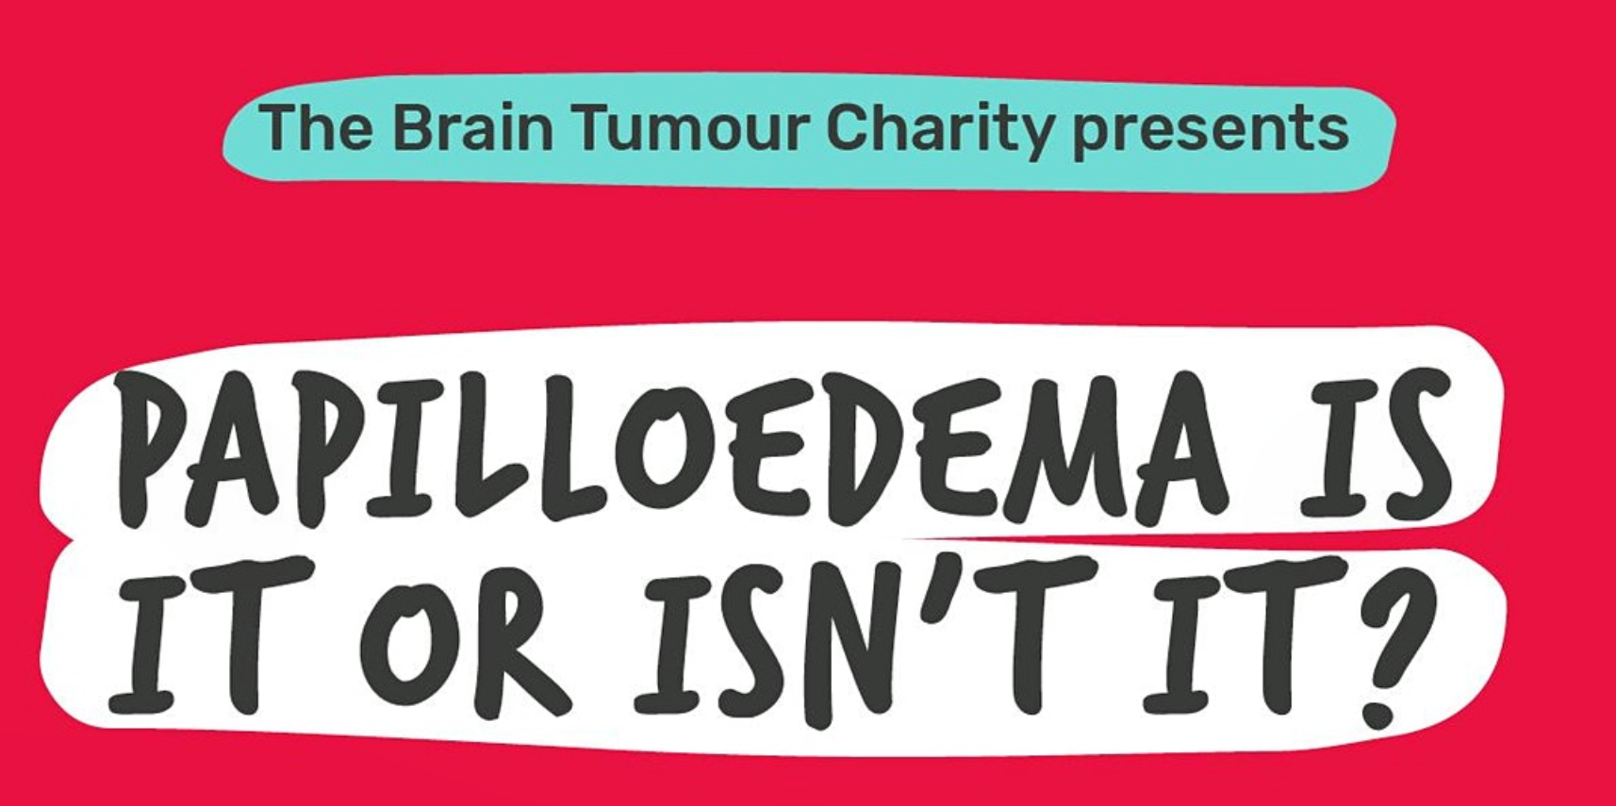

20th January 2021 7pm South East Region LOCs.
https://papilloedema-is-it-or-isnt-it-20-january-2021.eventbrite.co.uk

About this Event
Join our live webinar to hear Lorcan Butler, Optical Engagement Manager, and Susan Mollan, Ophthalmologist discuss different strategies for the management of Papilloedema. This life-threatening condition needs urgent emergency referral when detected, however there are still a large number of False Positive Referrals being made into Secondary Care.
This lecture style presentation will last approximately 35-40 minutes, followed by a live Q&A session. The presentation will be broken down into 3 main categories
- Papilloedema
- Pseudopapilloedema
- Differential Diagnosis between these two conditions
And will discuss other strategies we can utilise in the management of suspicious elevated Optic Discs.
About our speakers
Lorcan Butler is a qualified Dispensing Optician and Optometrist, and is the Optical Engagement Manager for The Brain Tumour Charity. His role is to educate people of the UK optical profession, in the importance of early detection of brain tumours in an eye examination.
Lorcan has a proven track record of educating people within the profession, being a Pre-Registration Supervising Optometrist for 10 different students over a 13 year period with Vision Express.
He is a College of Optometrists Council member for Northern Ireland. Lorcan is also a Council member for Optometry Northern Ireland.
Susan Mollan is a Consultant Neuro-Ophthalmologist at Queen Elizabeth Hospital Birmingham and is Society Secretary for UKNOS (United Kingdom Neuro Ophthalmologists Society). Susan's professional research specialities include; Idiopathic Intracranial Hypertension (IIH) and Papilloedema. Susan also has a huge interest in the quantification of disease through ocular imaging and is currently working on how OCT can be used as a surrogate marker for management of Intra-Cranial Pressure (ICP) in IIH.
This session will be hosted on Zoom. This registration allows us to capture the GOC information so that we can allocate the CET points post event. Once you register, you will be sent the session joining link to your email, please use this link to join the Webinar at the time of the session.

Date And Time

Date And Time
Wed, 20 January 2021
19:00 – 20:00 GMT
Add to Calendar

https://papilloedema-is-it-or-isnt-it-20-january-2021.eventbrite.co.uk

