**DDICB contracted providers for secondary care Ophthalmology services – January 2025**

NHS Derby and Derbyshire ICB contracts with a number of NHS and Independent Sector providers for secondary care Ophthalmology services in Derbyshire – there have been recent changes to these contracts, please destroy any previous versions of this information that you may have. These contracts and services are detailed below for your information. Providers with a contractual arrangement with Derby & Derbyshire ICB have had all due diligence checks undertaken and are obligated to adhere to all DDICB policies, so as such the recommendation is to refer to those listed below.

Contracts in place for secondary care **Cataract Surgery services** in the following areas of Derbyshire with;

* Chesterfield Royal Hospital
* University Hospitals Derby and Burton
* Newmedica – Chesterfield
* Spamedica – Derby and for High Peak and Glossop patients - Manchester, Sheffield, Newcastle-Under-Lyme and Oldham sites, Chesterfield
* Practice Plus Group (PPG) – Chesterfield
* CHEC – Chesterfield

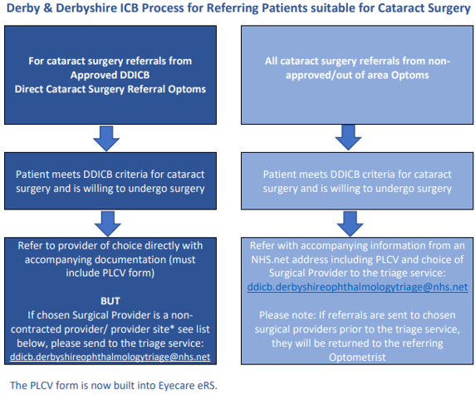

**\*DDICB contracts with providers for specific sites only, if the site isn't included in the list above then the Approved DDICB Direct Cataract Referral Optometrists must send the referral via the triage service.** For example: If a patient requested a referral to a Spamedica site not listed here or a patient requests a referral to a cataract surgery provider not listed here, in these examples the referral would need to be sent to the triage service at the email address above.

Contracts in place for secondary care **Age Related Macular Disease (AMD)** services in the following areas of Derbyshire with;

* Chesterfield Royal Hospital
* University Hospitals Derby and Burton
* Eyecare Medical – High Peak

Secondary care for **Glaucoma** services.

Both acute providers; Chesterfield Royal Hospital and University Hospitals Derby and

Burton. Our patients also have a choice of a range of other NHS hospitals around Derbyshire

including:

* Sheffield Teaching Hospitals NHS Foundation Trust
* Nottingham University Hospitals NHS Trust
* University Hospitals of Leicester NHS Trust
* Sherwood Forest Hospitals NHS Foundation Trust
* The Rotherham NHS Foundation Trust
* Stockport NHS Foundation Trust
* East Cheshire NHS Trust
* Manchester University NHS Foundation Trust
* Doncaster and Bassetlaw Teaching Hospitals NHS Foundation Trust