**Attention Driving Licence**

**holders**

In accordance with the advice

shown on the driving licence,

any driver with impaired vision

should inform the DVLA, who

will consider each case on an

individual basis.

Contact the DVLAat:

Drivers Medical Branch

DVLA

Swansea

SA99 1TU

**Does poor eyesight**

**sometimes make**

**your life difficult?**

**You may benefit from**

**advice and support**

**that your local council**

**social services**

**department (or its**

**designated agency)**

**can provide for you.**

**Your council has a duty to:**

•

Advise you of the range of

services available to people

with sight problems

•

Carry out an assessment of

your needs

These services can include:

•

Supply of special equipment

•

Training to manage daily tasks

•

Arranging for you to be

registered (if your eye

specialist determines you

are eligible and you consent).

**Do you have a**

**visual**

**impairment?**

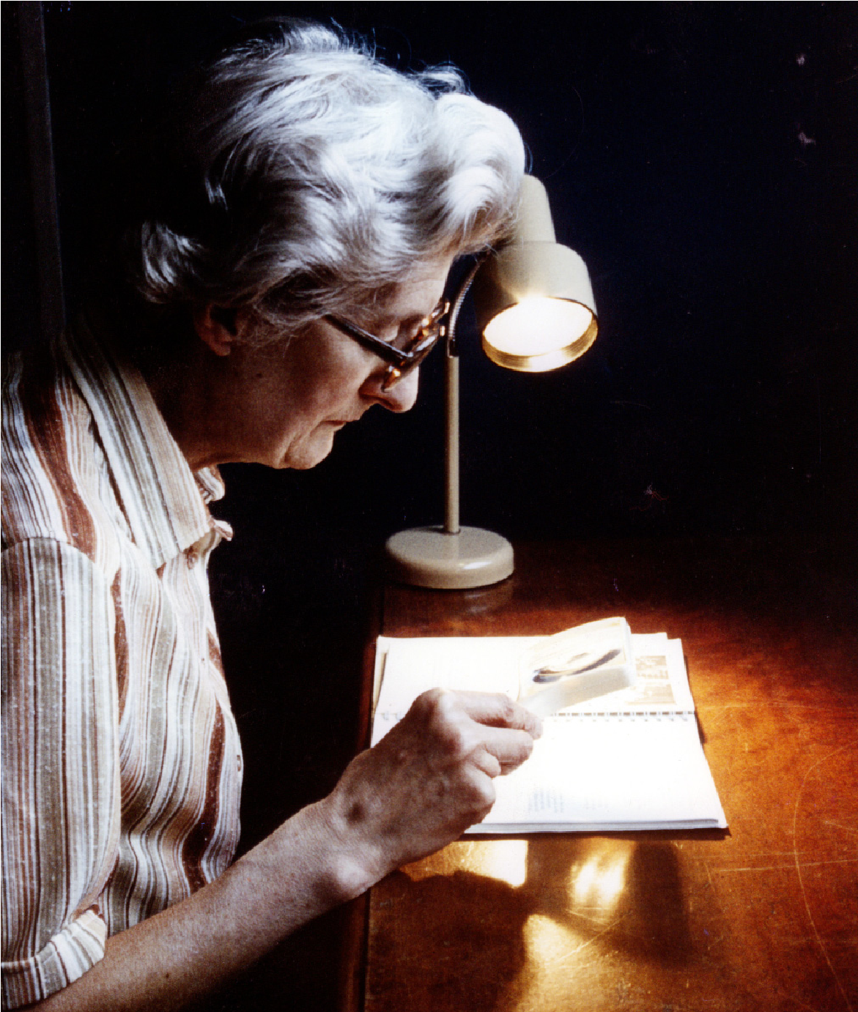

Provided by

**Local information**

**and Services**

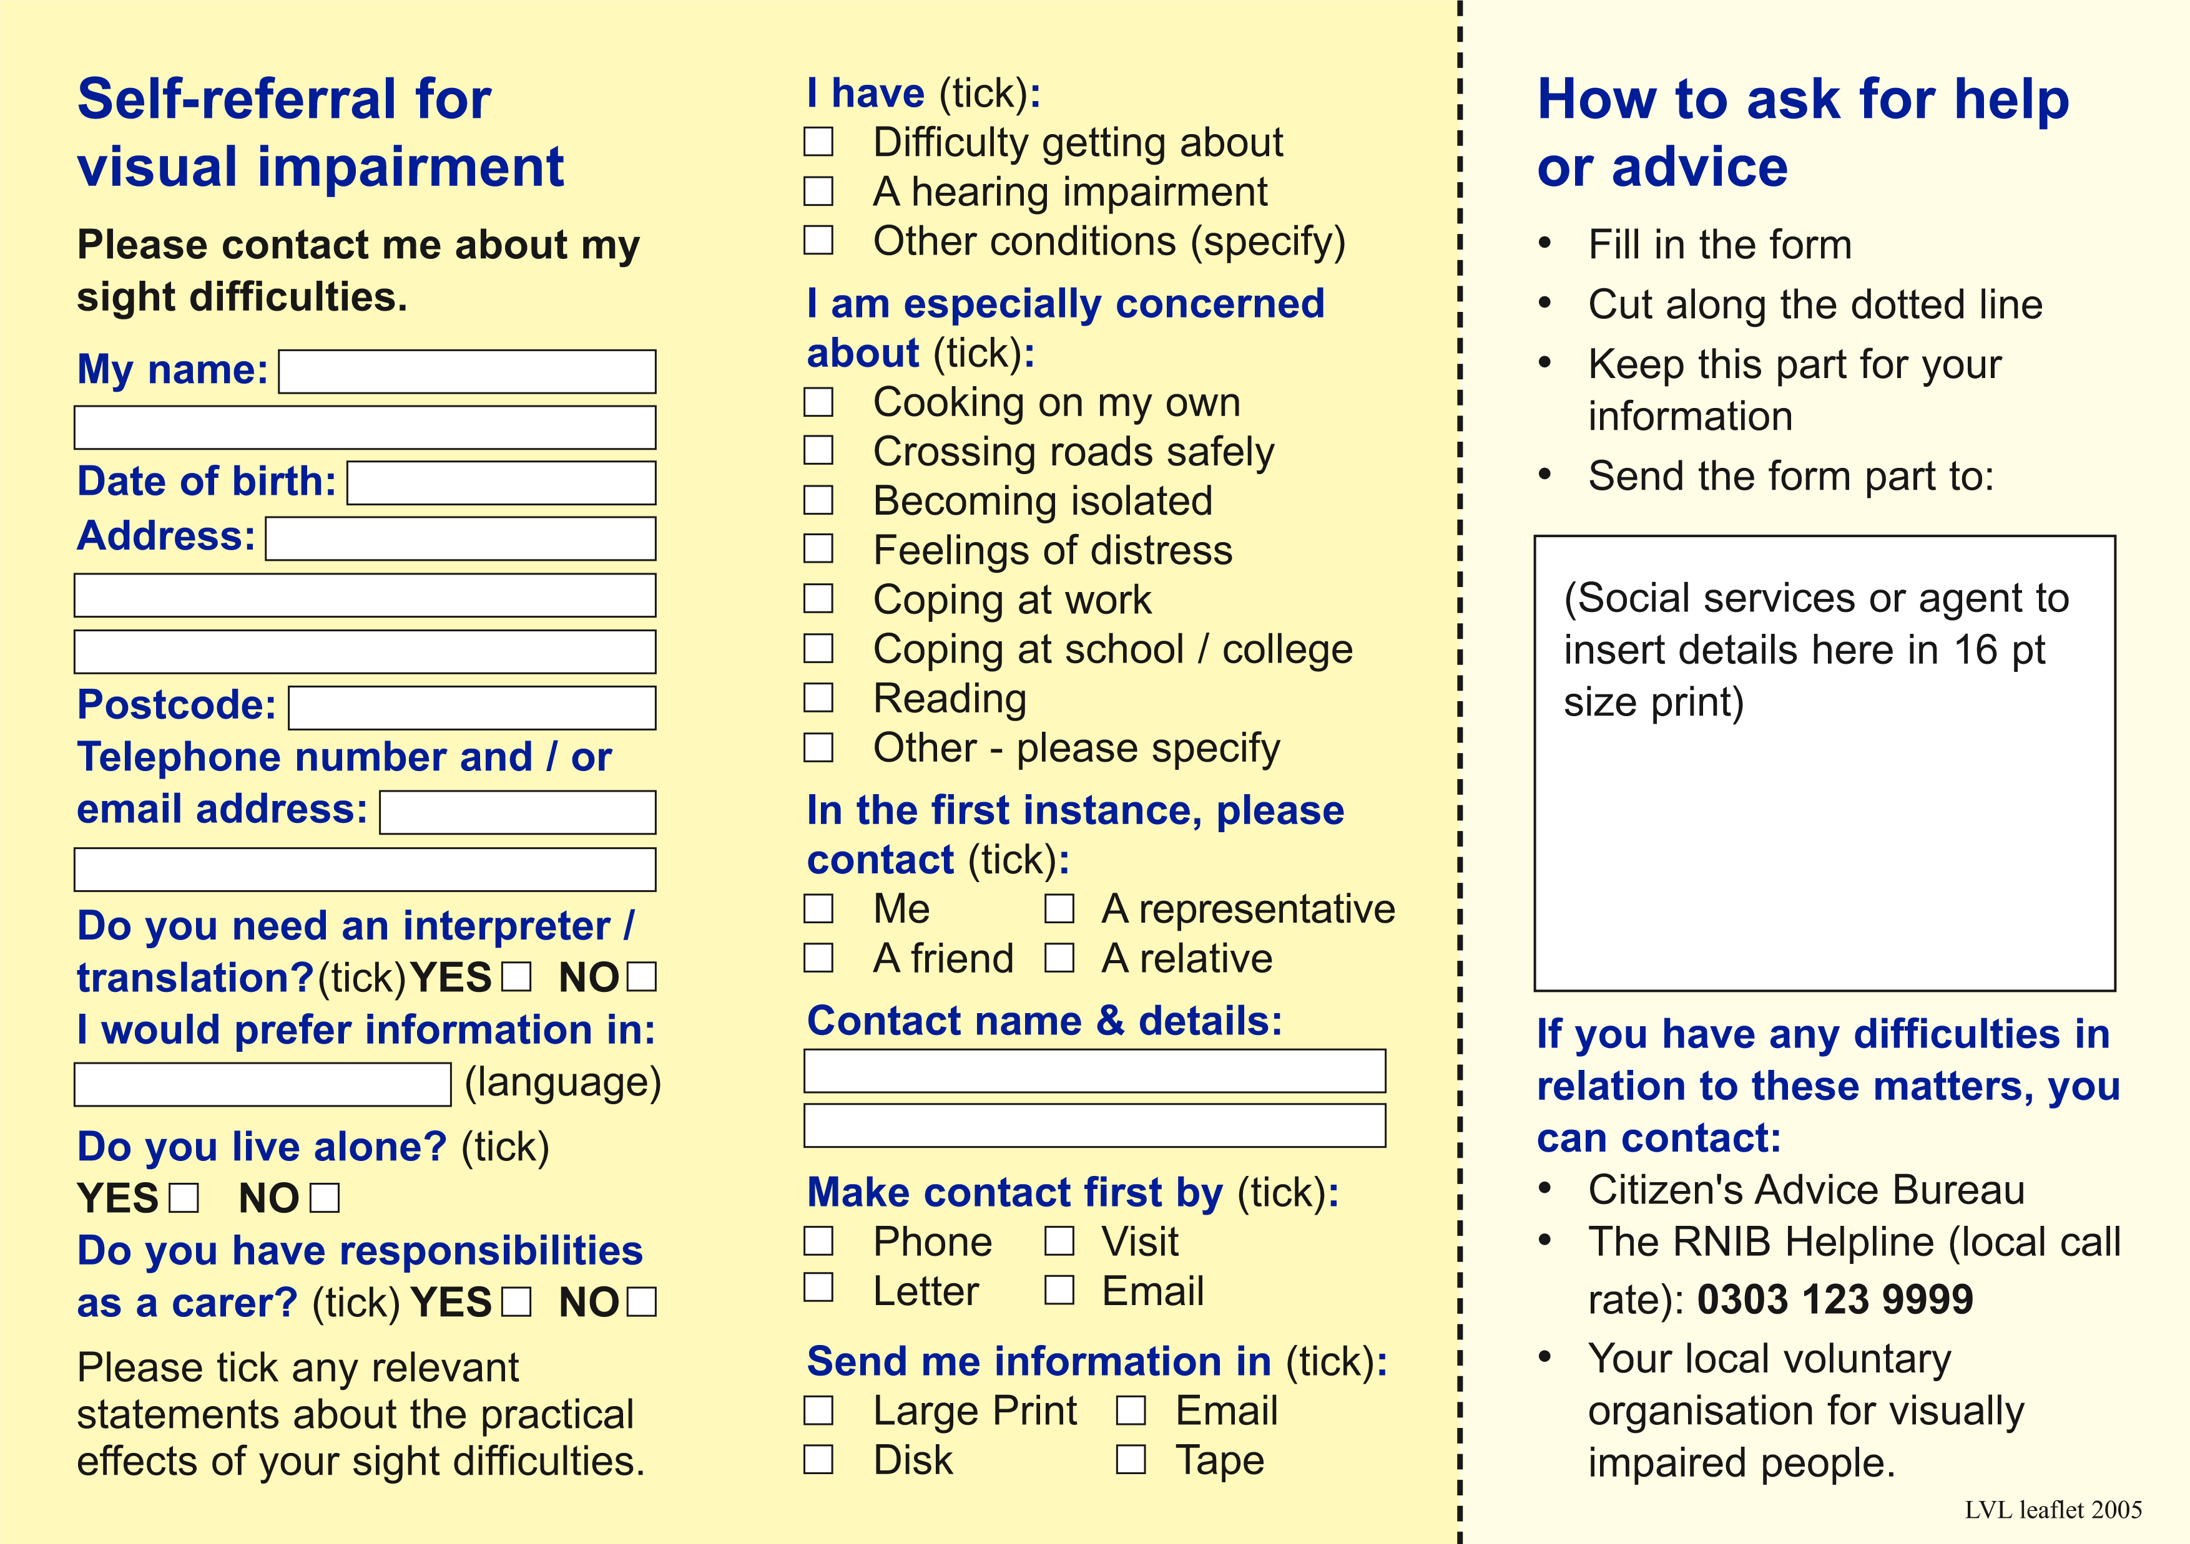

Derby City Council

Council House, Corporation Street, Derby

DE1 2FS