**REFERRAL PROTOCOLS FOR THOSE WITH A SOUTH WARKS GP**

J Belcher 12th August, 2020

Updated April 2021

Due to the different surrounding CCG’s opinions, we have slightly different referral protocols across Coventry, Rugby, North & South Warwickshire at the moment. Please check where the patient’s GP is based and refer as needed. This document is for those patients with a South Warwickshire GP.

**All** referral letters are sent to Community Health and EyeCare (CHEC) via the CHEC portal for all patients with a South Warks GP. This portal communicates with the GP so please follow the procedure below for all referrals and do not post letters to the GP! You can still refer patients who are under 16 years old via their GP however CHEC will also triage these patients too. CHEC do not triage these patients, they are redirected to pediatrics instead.

Write your referral letter as normal and then save a copy as a PDF or JPEG. Remember, you do **not**

need to print and post a copy of your letter to the GP!

Open the CHEC portal in your internet browser. https://system.communityhealthservices.co.uk



CHS Ophthalmology Admin System

**Email address**

Email address...

**Password**

Password...

Log in

© 2020 Community Health & Eyecare Ltd

Community Eyecare

Ophthalmology Administration System

**Logged in as: specsavers.stratforduponavon0368@nhs.net (Guest Optom) Logout**

Last login: 11:59am 12th August 2020

CHEC Referral Submission

! Patient Information

" Urgency

**First name \***

**Priority Type \***

Routine

Urgent

Two Week Wait

wAMD

**Last name \***

# Files / Supporting Documents

**Gender\***

Female Male Not Known Not Specified

**Address \***

**Name / Ref**

**File**

Name for file #1

Choose File no file selected

Name for file #2

Choose File no file selected

**Postcode \***

**Date of birth \***

Name for file #3

Choose File no file selected

**NHS/GHA Number**

Name for file #4

Choose File no file selected

**Phone Number \***

Name for file #5

Choose File no file selected

Submit $

Home | Logout

© 2020 Community Health & Eyecare Ltd

Last name...

First name...

The logins & passwords are sent to each individual practice when you register with CHEC.

Please email [bridget.m@chec.uk](mailto:bridget.m@chec.uk) and Bridget will arrange for your log-in and password to be sent to you if you do not have them already.

The above link takes you to the referral portal page as shown here.

Fill out all the boxes needed (NB we probably will not have the NHS number) and upload the referral pdf that you saved earlier but don’t forget to name the file on the portal. You can upload 5 files per referral if you wish to add OCT scans or photos etc.

|  |
| --- |
| Address... |
| Postcode... |
| Date of birth (dd/mm/yyyy)... |
| NHS/GHA Number... |
| Telephone... |

Then click submit. Your referral will then be triaged and referred on as needed, the GP will also be informed at this stage. Should the patient wish to attend a certain provider, then please put this in the referral letter.

Please note, from 1st September, CHEC can

also handle Wet ARMD referrals. Please select the correct ‘Priority type’ under ‘Urgency’ for your referral.

There are a few exceptions for certain patient referrals:

Exceptions:

*The exceptions to this referral procedure are:*

* **Emergency referrals** – Please see relevant briefing as this is changing at the time of writing.
* **Direct referral** for Diabetic Macula Oedema, Retinal Vein Occlusion and Wet ARMD can be emailed to Warwick/Stratford eye department (swft) on [ophthalmologyurgentref@swft.nhs.uk](mailto:ophthalmologyurgentref@swft.nhs.uk) should you wish to rather than using the CHEC portal.

# Minor Eye Condition Scheme

Patients can be seen by an appropriately qualified and accredited Optometrist on point of contact as of 27th January, 2020 for the following conditions:

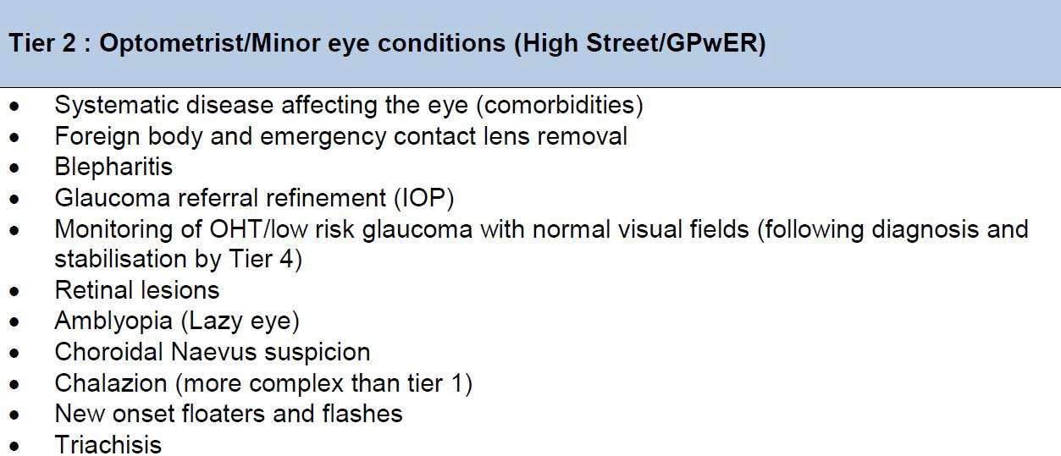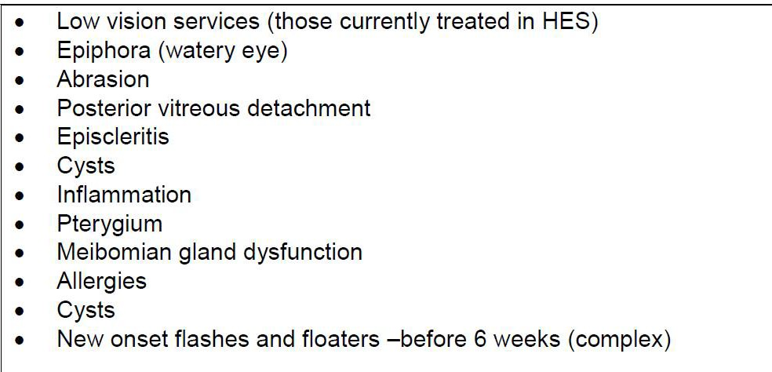

Please note, you may wish to ask for the patient’s consent as these appointments use a different part of the CHEC portal rather than your own practice management system/records.

A Consent button has been built into the portal and you can still keep a copy of the records if the patient agrees.

# Extended Ophthalmic Service appts

**IOP reﬁnement**

If the IOP is found on non-contact tonometry to be over the NICE guideline threshold **without any other signs of glaucoma**, the patient should have Goldmann applanation tonometry performed on them by an accredited Optometrist and enter into the IOP reﬁnement service oﬀered under CHEC.

The NICE guideline threshold is age dependent, and at the time of writing, is as follows:

<80 years …. > 24mmHg

>80 years …. > 25mmHg

# Glaucoma Referral Reﬁnement Scheme

If other signs of glaucoma are present (ie suspicious discs, OCT, anterior angles or ﬁelds) then the patient should be referred into the Glaucoma Referral Reﬁnement Scheme so that an accredited Optometrist can assess the patient. If there is not an accredited Optometrist in your practice, then your patient should be referred via the CHEC portal who will direct the patient to a local accredited provider.

# Accreditation:

Please contact Bridget (bridget.m@chec.uk) to arrange accreditation with CHEC to provide the Extended Ophthalmic Services and MECS as above.

Otherwise, you can refer on to a local accredited Optometrist by uploading your referral to the CHEC portal and the referral will be triaged and directed appropriately.