CONSULTANT CONNECT step by step guide:

Consultant connect is an advice line which is run by either an Optometrist or a consultant. It is NOT used as a referral service. Consultant connect is not the appropriate service for any acute symptoms, for this the Eye Casualty Emergency referral (or e-referrals) is the appropriate pathway.

This is a service used if you’re unsure of the referral pathway of a patient i.e. Eye Casualty or outpatient clinic.

Search https://www.consultantconnect.org.uk/ into your web browser. Then click on sign in, top right corner. There is a tab on the page that says sign up which will take you to the screen below. You can also have access to this on your mobile phone through the consultant connect app.

1) You will need a secure email (nhs.net) account to sign up for this.

Follow the steps below once signing up.

2) Organisation’s name is your practice address, NOT UHCW.

Enter your role. The NHS registration number is your GOC number.

Verification will be sent via email. You can also enter your mobile number and it may ask you to verify this way also.

Once signed up it should take you to this page (homepage). To send a message for advice, clinic on the messages tab at the top.

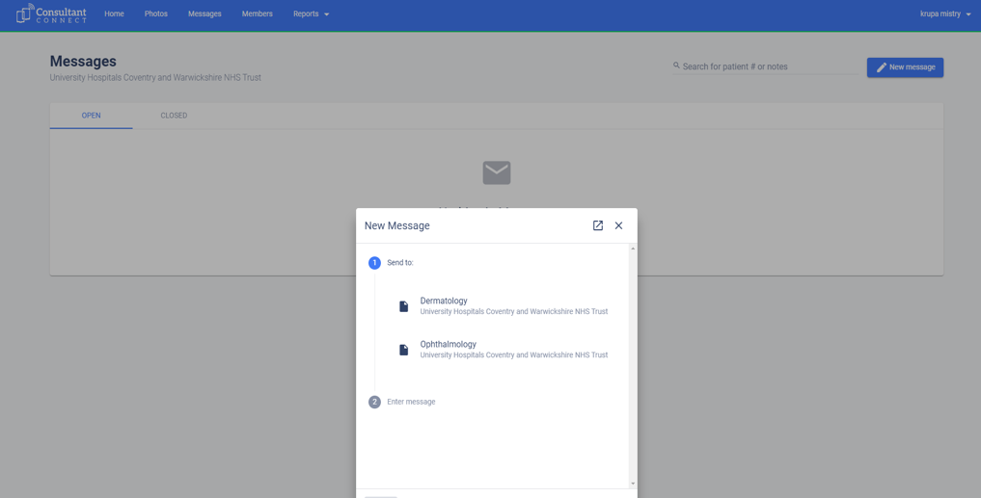
Choose the speciality, which in this case would be ‘ophthalmology’

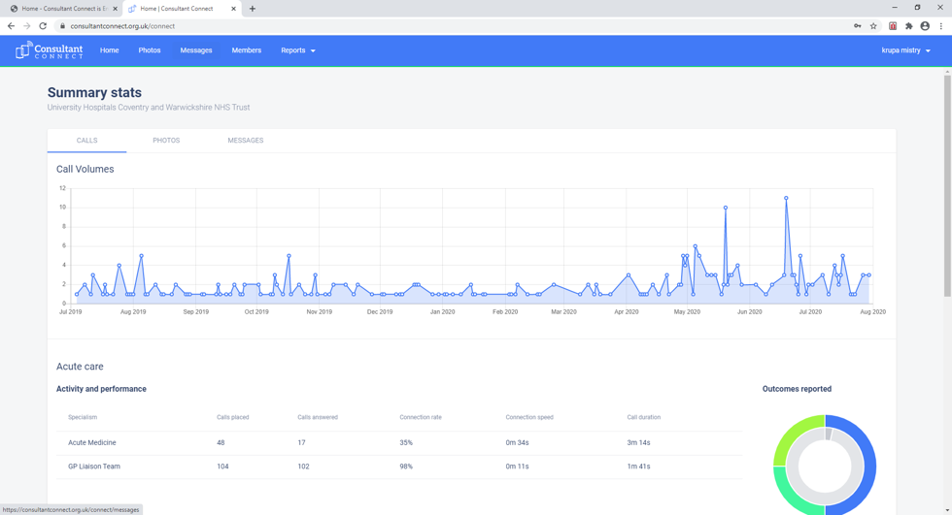

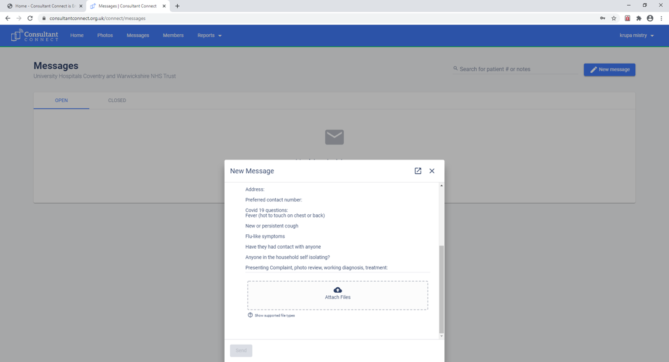
Fill in as much information as possible when sending in your query for advice. You can also attached photo’s (such as OCT, fundus photo’s etc). Once sent, a clinician at UHCW will respond to you.

You can also get consultant connect as an app on your mobile phone so if you work at a practice that may not have a computer or limited internet access, the app may work well for you.

