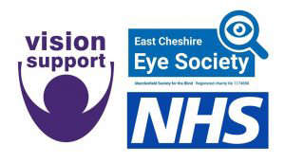

PRESS RELEASE
For Immediate Release
Organisations working in partnership – Vision Support, East Cheshire Eye Society and NHS England
NHS England, Vision Support and East Cheshire Eye Society are working together to improve information for people living with a sight loss in Cheshire.
If you have sight loss, it can be difficult to find out information to support you, and about activities in your local area. We want to hear your views so we can improve access to information and by completing a short survey, you will be offered the chance to take part in a Prize Draw.
To request a paper copy of the survey and a free return envelope, or to complete the survey on the telephone with one of our friendly staff just give us a call on 01244 381515 or email: information@visionsupport.org.uk
The survey can also be completed online at: http://visionsupport.org.uk/surveys/ and responses need to be returned by the 1st August 2022.
Chris Duggan who has a vision impairment and has been volunteering to help with the project said “
Picture of Chris.

