A physical manifestation of this abuse can be eye injuries, an area that falls under the purview of opticians. The issue of domestic abuse is significant due to its widespread occurrence and severe, often long-lasting, impacts on victims. Opticians can play an essential role in identifying potential abuse due to their unique position of regular contact with the public.
Why it matters
3
1
What is it?
Behaviour of a person towards another person is “domestic abuse” if—
a) they are each aged 16 or over and are personally connected to each other, and
b) the behaviour is abusive.

(Domestic Abuse Act 2021)

2
What is it?
Behaviour is “abusive” if it consists of any of the following—
- physical or sexual abuse;
- violent or threatening behaviour;
- controlling or coercive behaviour;
- economic abuse;
- psychological, emotional or other abuse
(Domestic Abuse Act 2021)

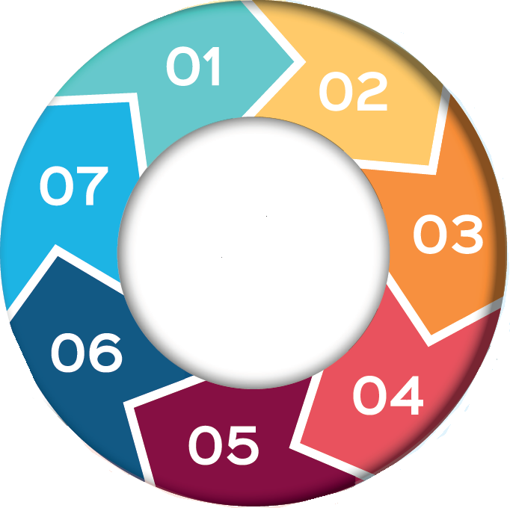

Domestic
Abuse

7 What should we do?
4
- Accurately document any signs or symptoms of abuse in the patient's records.
Through routine eye examinations, opticians may notice physical signs of abuse or changes in a patient's emotional wellbeing. Recognising these signs can be the first step towards intervention and, ultimately, protection of victims.

Why it matters
- Show empathy and let the patient guide the conversation, recognising that they may not be ready to disclose their experiences.
- Consult with the Safeguarding Lead who can guide you on the next steps, which may involve contacting the local authority's safeguarding team.
- Provide the patient with contacts for organisations such as the National Domestic Violence Hotline or local support services.
5
What is the impact?
- Opticians should remember their role is not to intervene directly but to support and guide patients to the right resources, always maintaining patient safety, confidentiality, and trust.
The impacts of domestic abuse are broad and deep, affecting the victim's physical and mental health, social interactions, and overall well-being. Eye injuries as a result of such abuse can have serious, lasting consequences on vision, leading to partial or complete blindness in extreme cases. From a societal perspective, the repercussions are also severe, contributing to increased healthcare costs, community instability, and intergenerational cycles of abuse.

6 What should we do?

- Be vigilant and sensitive to signs of potential
abuse.
- These signs might include recurring injuries around the eyes, unconvincing explanations about the cause of injuries, or sudden changes in behaviour.

