The general and service conditions declaration
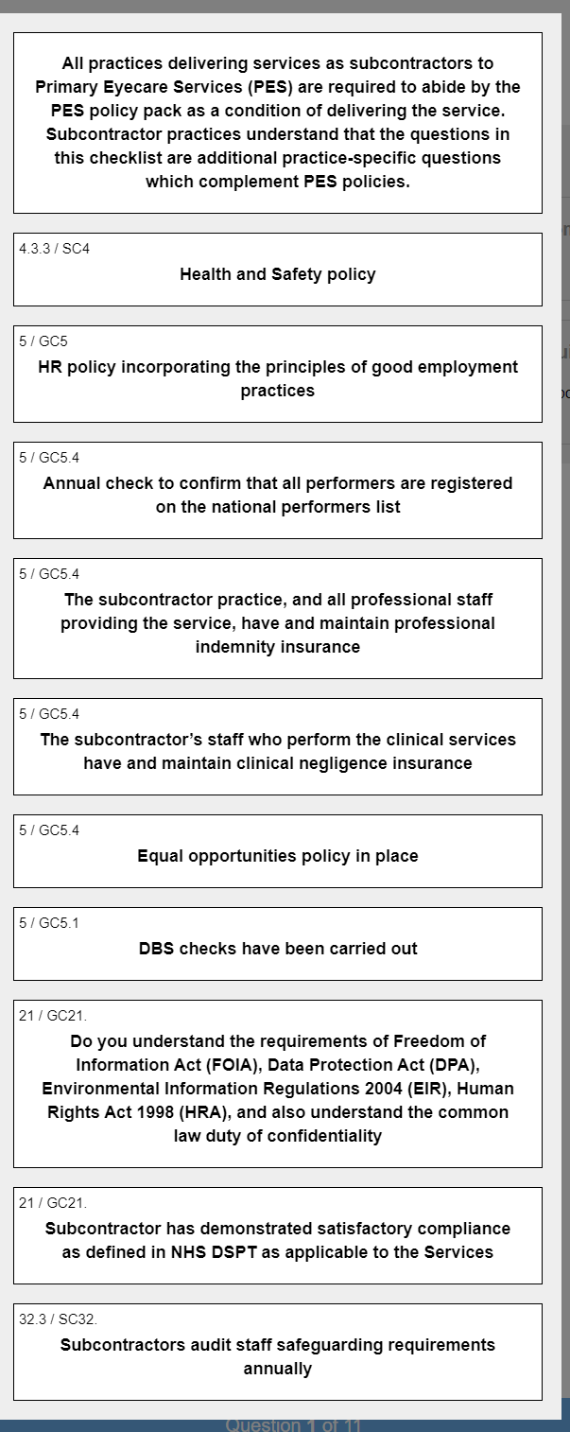
The following relates to information governance as well as DSPT
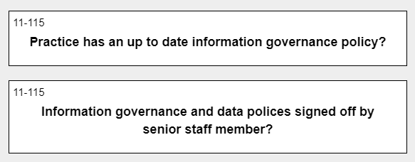
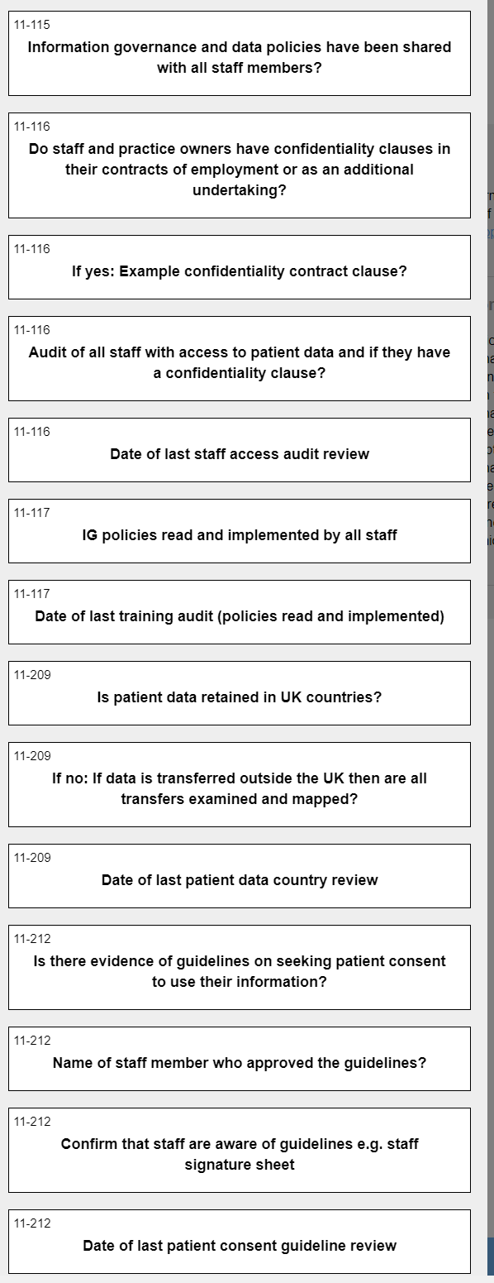
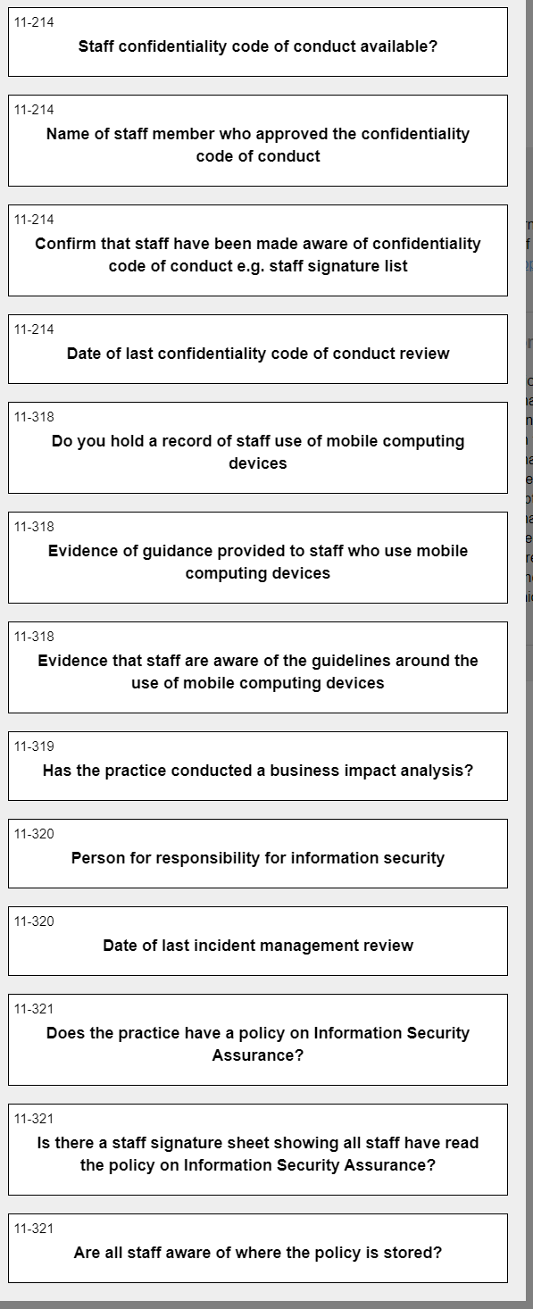
Extract from QIO NHS Standard Contract contractors with Primary Eyecare Services Ltd

